**Final Design Report**

***Next-Generation Subsea ROV***

**Prepared For:**

**Mr. William Ledbetter**

**Mr. Don Wells**

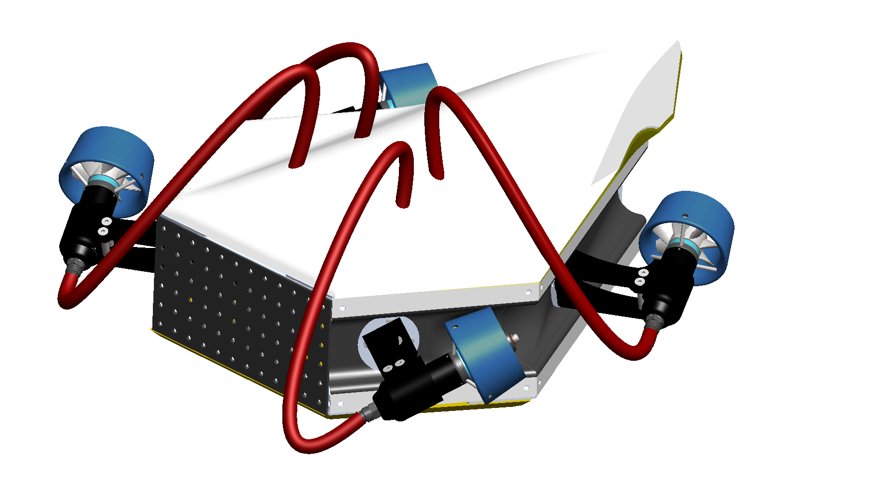



Presented to

Dr. Andrew Conkey

Prepared by: Ocean Gig

Eric Bauman

Bobby Clukey

Heath Garrett

Marcus Navas

David Scott

Texas A&M University

Department of Multidisciplinary Engineering

ITDE 402 – Spring 2025 – Sections 501/M01

April 21, 2025

# Executive Summary

Next-Generation Subsea ROV

When divers operate underwater, they encounter numerous hazards inherent to the environment. To reduce these risks, underwater remotely operated vehicles (ROVs) have been developed to minimize the need for direct human involvement in dangerous conditions. However, current ROVs lack the ability to move and perceive their surroundings with the same flexibility and precision as a human diver. The objective of this project was to develop an ROV capable of replicating diver-like movement and performing tasks typically executed by divers. The specific focus for this team was the design and construction of the chassis and propulsion systems.

At the start of the semester, preliminary progress had been made in computer-aided design (CAD), and many analytical aspects of the project had been outlined. However, all work up to that point remained theoretical, with no physical components assembled. The only available hardware consisted of thrusters that had been generously donated, as well as the electronics to power these thrusters.

This report presents the analytical diagrams and charts used to identify critical needs, functions, and design solutions that contributed to the development of the final product. It also includes financial documentation to confirm the project remained within budget, along with a detailed overview of the ROV’s construction process.

The completed project resulted in a fully built ROV chassis with thrusters capable of providing six degrees of freedom. This configuration enables the ROV to maneuver through water in a manner that closely simulates the movements of a human diver. With this completed model, the team was able to test the 6-degrees of freedom of the ROV, the strength of the ROV, and attempted to test the force output of the thrusters given different power inputs.

Special recognition is extended to Professor William Ledbetter and Mr. Don Wells for their generous support throughout the project, and to Dr. Andrew Conkey and Professor Oscar Lopez for their assistance throughout the capstone project. Appreciation is also given to members of Oceaneering International, Inc. for their valuable insights and willingness to share their expertise in subsea ROV technology.

# Demonstration of ABET Student Outcomes and Performance Indicators

| **Student Outcome (SO)** | **Performance Indicator (PI)** | **Page Numbers in this Report Showing Demonstration  of this SO/PI** |
| --- | --- | --- |
| SO 1: An ability to identify, formulate, and solve complex engineering problems by applying principles of engineering, science, and mathematics | 1-A. An ability to identify complex engineering problems and initiate problem-solution processes | Pages 7-13 |
| 1-B. An ability to carry out an engineering problem solution process to completion | Pages 24-28 |
| 1-C. An ability to apply fundamental principles of engineering, science, and mathematics in an engineering problem-solution process | Pages 22-23  Pages 30-32 |
| SO 2: An ability to apply engineering design to produce solutions that meet specified needs with consideration of public health, safety, and welfare, as well as global, cultural, social, environmental, and economic factors | 2-A. An ability to determine needs to be satisfied by an engineered solution and interpret and consider needs in contexts of health, safety, welfare, global, cultural, social, environmental, and/or economic contexts, as appropriate. | Pages 33-35 |
| 2-B. An ability to implement a logical, orderly, and documented design process driven by defined needs. | Pages 14-21 |
| SO 5: An ability to function effectively and professionally on a team whose members together provide leadership, create a collaborative and inclusive environment, establish goals, plan tasks, and meet objectives | 5-A. An ability to function effectively on a team by contributing to the team effort through collaboration and the creation of a collaborative and inclusive environment. | Pages 38-40 |
| 5-B. An ability to function effectively on a team by exercising appropriate leadership to establish goals, plan tasks, and meet objectives. | Pages 7-8  Pages 38-40 |
| SO 6: An ability to develop and conduct appropriate experimentation, analyze and interpret data, and use engineering judgment to draw conclusions and propose recommendations | 6-A. An ability to develop and conduct experiments appropriate for engineering applications. | Pages 22-23  Pages 30-32 |
| 6-B. An ability to analyze and interpret experimentally derived data. | Pages 22-23  Pages 30-32 |
| 6-C. An ability to use appropriate engineering judgment with analysis of experiments to formulate conclusions and propose recommendations. | Pages 22-23  Pages 30-34 |

**Final Design Report**

***Next-Generation Subsea ROV***

**Table of Contents**

Executive Summary 2

Demonstration of ABET Student Outcomes and Performance Indicators 3

List of Figures and Tables 5

Glossary/Nomenclature 6

Introduction 1

Project Recap 1

Concept Overview 3

Initial Concept 3

Modified Concept 5

Detailed Design Overall System 8

Functional Diagrams 8

Functional Analysis Diagrams (FAD)/Functional Flow Diagram (FFD) 8

Physical Layout Diagrams 9

Geometric Layout 11

Bill of Materials 13

Estimated Cost for Prototype 15

Detailed Design: Engineering Analysis 16

“The Build” -Fabrication/Construction/Production/Synthesis/Coding 18

Stage 1: Frame Construction 18

Stage 2: Thruster Arm Construction 19

Stage 3: Skin Construction 21

Stage 4: Electrical Connection 23

Testing/Verifying/Validating/Experimental Plan 24

Safety/Hazard Assessment and Evaluation 27

Reliability Assessment 28

Societal Factors and Impact 29

Future Work 30

Team and Project Organization, Planning, and Execution 32

Summary 35

Appendix 36

A. List of Abbreviations and Terminology 36

B. References 36

C. Order of Magnitude and Detailed Calculations 37

E. Detailed working drawings/models/assembly 38

F. Testing/Validating/Verification/Experimentation 39

# List of Figures and Tables

**Figure 1.** Chassis Subsystem House of Quality (team-fig) - 1

**Figure 2.** Propulsion Subsystem House of Quality (team-fig) - 2

**Figure 3.** Isometric drawing of The Turkey design. (team-fig) - 3

**Figure 4.** The final fall semester CAD drawing (team-fig) - 4

**Figure 5.** The mid-semester model of the ROV (team-fig) - 6

**Figure 6.** The final design of the ROV without the syntactic foam (team-fig) - 7

**Figure 7.** The final design of the ROV with the syntactic foam (team-fig) - 7

**Figure 8.** Functional Analysis Diagram for the subsea ROV. (team-fig) - 9

**Figure 9.** Physical layout of the chassis and propulsion subsystems (team-fig) - 10

**Figure 10.** Wiring diagram for the thruster power and control system provided by Tecnadyne. (Tecnadyne) - 10

**Figure 11.** Internal view of the ROV showing the electronics, syntactic foam, frame, rotary actuators, and thruster. (team-fig) - 11

**Figure 12.** Exploded view of the ROV showing the key components of this phase of the design project. (team-fig) - 12

**Figure 13.** Calculations of Archimedes’ Principle in SolidWorks. (team-fig) - 16

**Figure 14.** A team member cuts an aluminum bar using an FEDC chop saw. (team-fig) - 18

**Figure 15.** The completed aluminum frame of the chassis. (team-fig) - 19

**Figure 16.** A team member prepares to bend the aluminum section of the thruster arms. (team-fig) -20

**Figure 17.** A thruster sitting in the thruster clamp and aluminum arm. (team-fig) - 20

**Figure 18.** Top skin panel with space for the clips on the thruster tubing. (team-fig) - 21

**Figure 19.** Port isometric view of the ROV with the skin panels (team-fig) - 22

**Figure 20.** Starboard isometric view of the ROV with the skin panels (team-fig) - 22

**Figure 21.** The wiring for the power subsystem is connected to the subsea thruster. (team-fig) - 23

**Figure 22.** Stress/strain curve for 5052 Aluminum (team-fig) - 24

**Figure 23.** Stress heat map for a 50-pound force acting on the thruster clamp acting downward with the thruster arm horizontal (team-fig) - 25

**Figure 24.** Stress heat map for a 90-pound force acting on the thruster clamp acting downward with the thruster arm vertical (team-fig) - 26

**Figure 25.** The WBS for the design and manufacturing process. (team-fig) - 33

**Figure 26.** The projected Gantt chart for the semester. (team-fig) - 33

**Figure 27.** The actual completion times for tasks are between March and April. (team-fig) - 34

**Figure C.1.** Calculations of Archimedes’ Principle in SolidWorks. (team-fig) - 37

**Figure C.2.** Excel representation of the resultant force and torque vectors given thruster positions and output forces. (team-fig) - 37

**Figure E.1.** Enlarged model of the wiring diagram for the thruster power and control system - 38

**Figure F.1.** Enlarged representation of the resultant force and torque vectors given thruster positions and output forces. (team-fig) - 39

**Table 1.** SWOT Analysis for the ROV (team-fig) - 5

**Table 2.** Bill of materials for the prototype (team-fig) - 13-14

**Table 3.** Cost estimate table for the project (team-fig) - 15

**Table 4.** Future work areas that will be covered in coming years (team-fig) - 30-31

# Glossary/Nomenclature

* CNC: Computer Numerical Control
* DOF: Degrees Of Freedom
* FAD: Function analysis diagram
* Full Depth Rated: Rated to withstand the pressures at the bottom of the Marianas Trench, the deepest part of the ocean.
* Propwash: The effect that thrusters have on the fluids passing through them. This effect makes the fluids rotate in a spiral pattern after passing through the propeller.
* ROV: Remotely Operated Vehicle
* SWOT: Strengths, Weaknesses, Opportunities, and Threats
* Tether (Umbilical): The wired connection between the ROV and the pilot on the surface which powers the ROV and controls the thruster directions and powers.
* WBS: Work Breakdown Structure

# Introduction

## 

## Project Recap

The goal of this project is to create a Subsea ROV that possesses the ability to move and see like a human diver. This constitutes characteristics such as the ROV having 6 degrees of freedom, access to 360 degrees of visibility, and having a borescope to be able to look around objects the way a human head/neck combination provides. From the QFDs (**Figures 1 and 2** ), the team determined the top-level measures that produce a successful project, including keeping the overall cost of the ROV minimal within the team's budget and keeping the maneuverability of the ROV ahead of the current industry leaders in subsea ROV about tether accommodation and thruster capability.

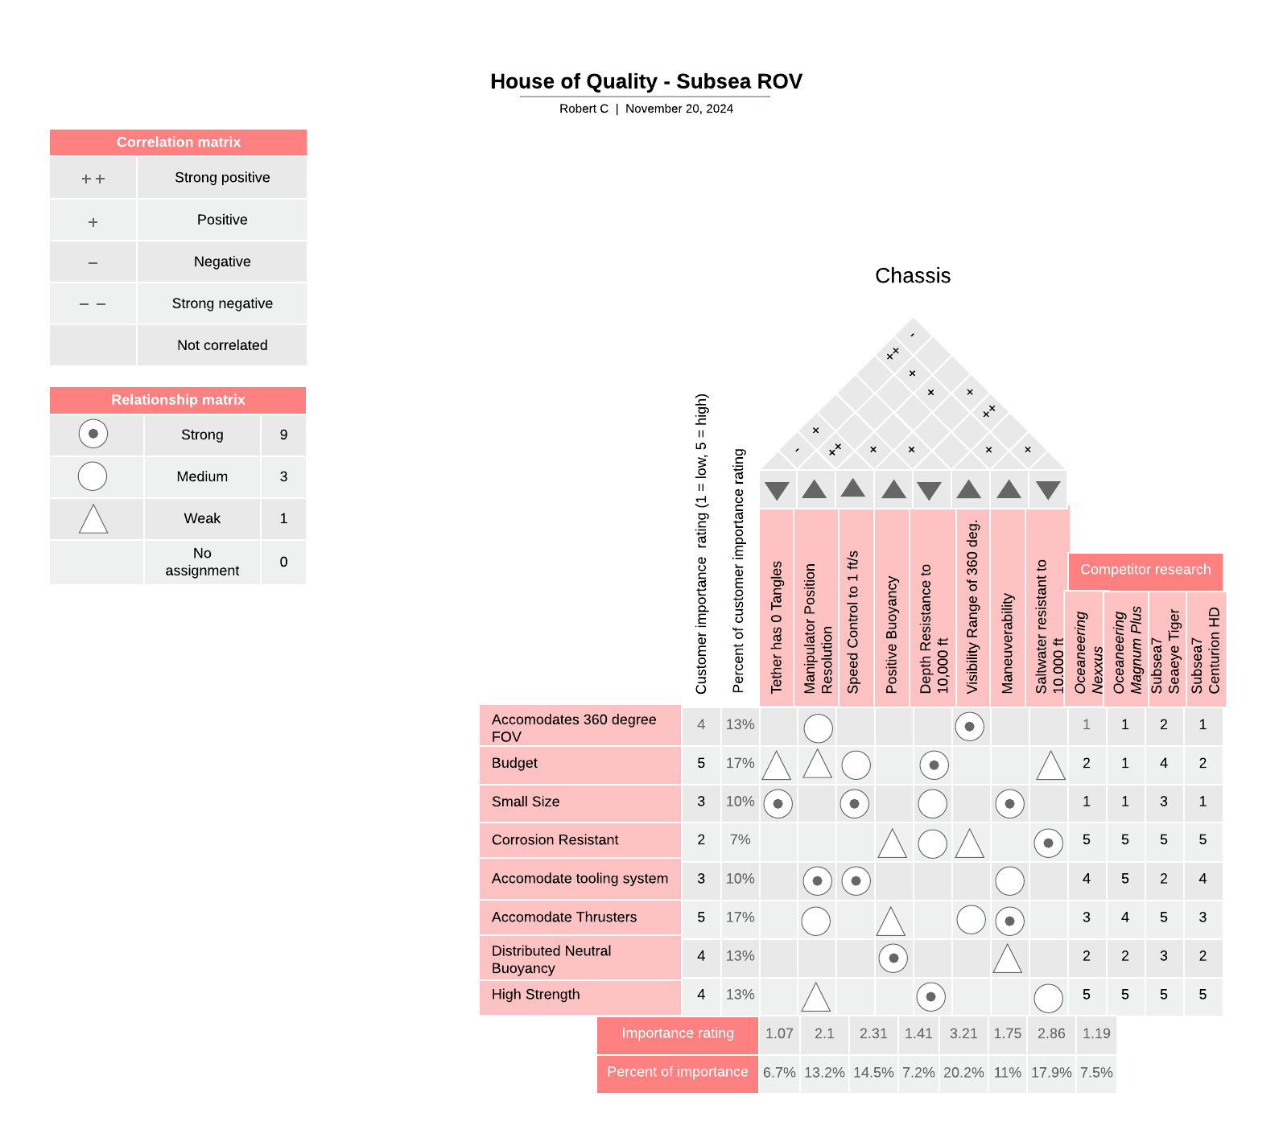

**Figure 1.** Chassis Subsystem House of Quality (team-fig)

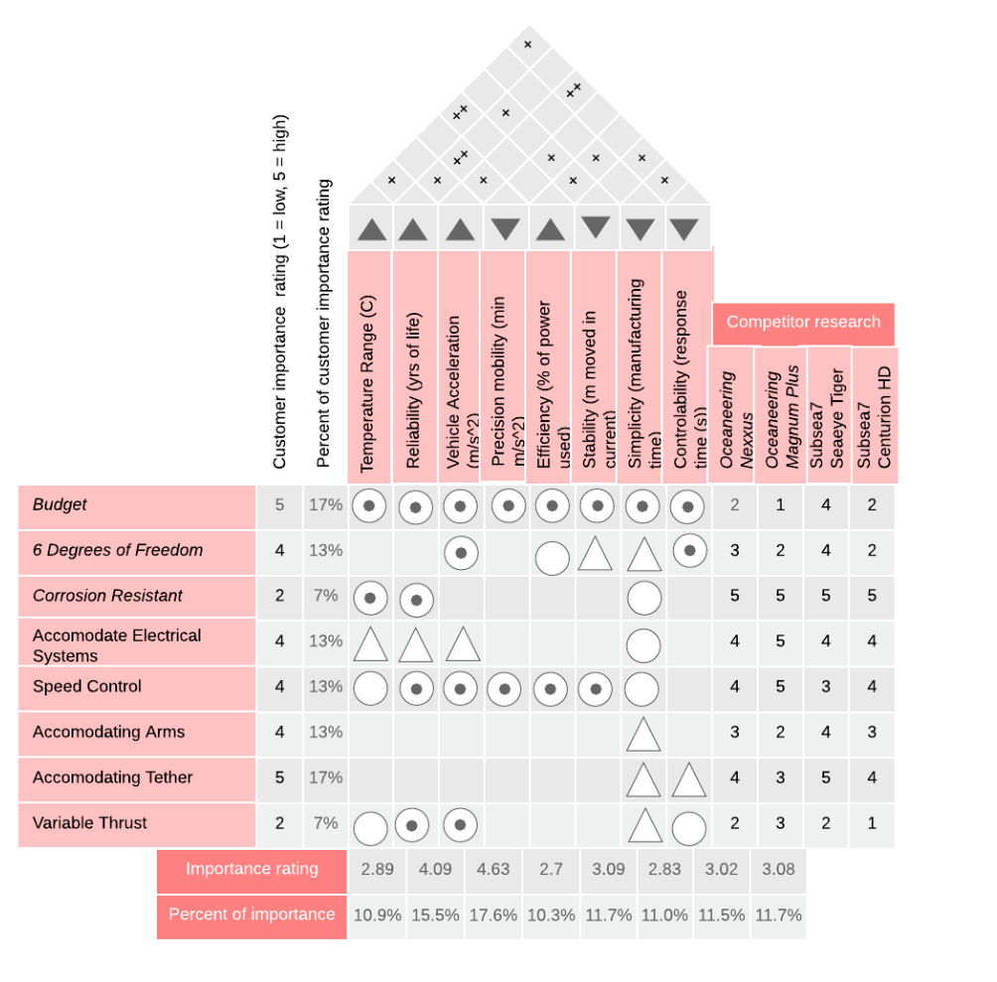

**Figure 2.** Propulsion Subsystem House of Quality (team-fig)

As the design progressed, the focus shifted to the more fundamental deliverables. A well-designed frame that provided efficient use of space to accommodate electronics, a buoyancy system, and the rotating thrusters were paramount. We also put a deeper focus on completing the mounting of the thrusters to be able to represent our proof of concept within the time frame we were working within. We kept the needs of the QFD in mind by prioritizing the design of the frame conscious of buoyancy, as that is the determining factor in an ROV that functions under the water, as well as making sure the thrusters can provide the control that is key to our project.

## Concept Overview

This section of the report covers the development of the initial solution to the need statement and how that concept evolved to the final design the team worked towards.

### Initial Concept

At the beginning of the semester, the dimensions of the frame had been essentially finalized, having decided on an optimum shape. The mounting location of the thrusters and rotary actuators was also known. The rotary actuators would not be implemented into the final design due to the heavy power needs, weight, and expensive cost. The skin panel shapes were also roughly determined based on the desire to create a hydrodynamic shape that provided strength as well as thruster, tether, manipulator, and camera accommodation.

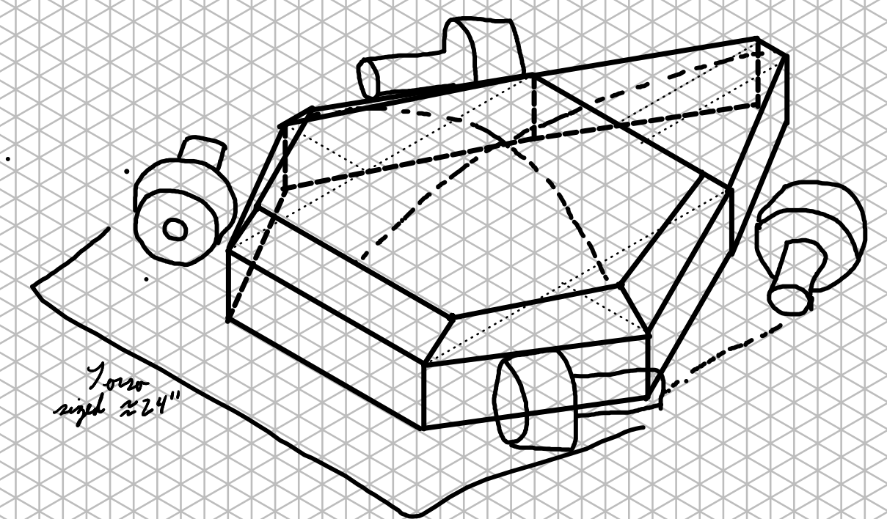

**Figure 3.** Isometric drawing of The Turkey design. The design was planned to be 24 inches long, 25 inches wide, and 10 inches tall. These dimensions are consistent with the prototype. (team-fig)

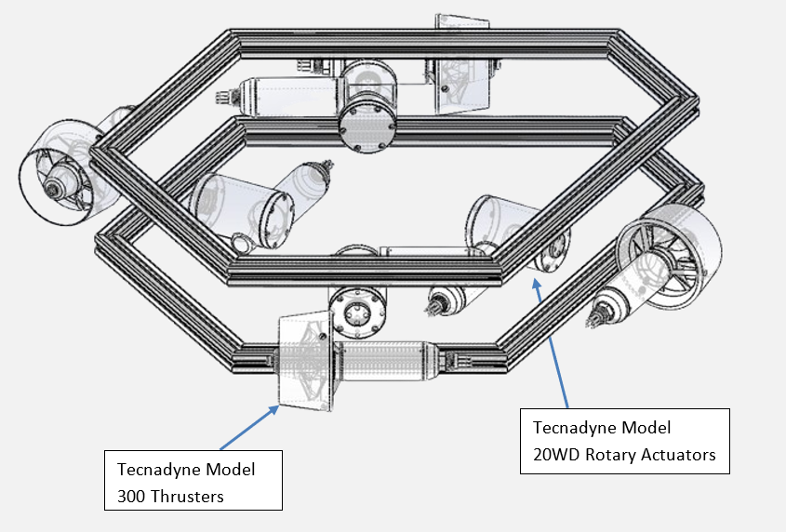

**Figure 4.** The final fall semester CAD drawing with the Tecnadyne Model 300 thrusters and Tecnadyne Model 20WD rotary actuators labeled. (team-fig)

Most of the strengths of the ROV project came from this being a multi-year project. As this was the third year of a five-year project, the team had two years of work to build upon. One of the strengths that didn’t come from the length of the project was the modularity and scalability of the design of the ROV. If the dimensions of the beams and the power of the thrusters were to be increased, the capabilities of the ROV, such as the payload and depth resistance, could also be increased.

The weaknesses of this project stemmed from the lack of experience the team had with certain parts of the project’s scope. Part of our work was to create the power system for the ROV. None of the team members in the project were power engineers, and as such, no one had experience working with the power system. Another weakness came from the project’s budget. The rotary actuators the team was going to use cost $12,000 each. This means the 4 rotary actuators that had originally been planned for would go well over the budget of $10,000.

The opportunities that this project has given the team come from the design of the ROV and the industry leaders who have been able to help with the creation of the ROV. The 6 degrees of freedom on the ROV provide multi-directional capabilities that mimic a diver’s motions. The team also worked with Oceaneering and The Subsea Tieback Foundation to determine how the current industry creates subsea ROVs and where the current solutions could be improved upon to create the next-gen ROV design.

The threats to the ROV project, much like the weaknesses, came from the lack of knowledge in power engineering. None of the team members were power engineers, and as such, the team needed to learn how to deliver the necessary power to the thrusters, rotary actuators, cameras, and manipulators for the ROV to function like a human diver. Another threat to the project, which can be a major problem in future stages of the project, is that the team’s sponsors specifically stated that marinization should not be a priority. This could affect how much of the team's work will be useful to the future years of the project. Something the team might have thought was important to design the ROV around might not be marinized, and as such would have to be replaced, thus changing the design of the project.

**Table 1.** SWOT Analysis for the ROV (team-fig)

| **Strengths:**   * Concept * Industry connections through sponsors * Static Mechanical analysis * Access to previously acquired parts * Access to previous work done * Modularity and scalability of design | **Weakness:**   * Undeveloped power system * Lack of full CAD model * Vagueness of certain specifications * Lack of access to CAD models for electrical components * Potential costs * Fluid analysis * Limited testing environment |
| --- | --- |
| **Opportunities:**   * Advanced Maneuverability * Size-accommodated exploration possibility * Innovation in overall geometry * Creation of a next-gen ROV that mimics the motions of a human diver * Modularity and scalability of design * 6 degrees of freedom | **Threats/Risks:**   * Needing expensive parts and possibly going over budget for specific pieces of equipment * Understanding of circuitry for power systems * Our part of the project is not concerned with marinization, which could cause compatibility issues further down the road * Combining previous groups' work into our frame |

### Modified Concept

The main shape of the ROV remained constant throughout the semester, however the externals of the ROV went through various changes to best shape for hydrodynamics, buoyancy, and overall ROV strength.

In the beginning of the semester, there was only the frame, thrusters, and rotary actuators in the ROV model. The dry weight for this version of the ROV was 46.2 pounds, while the wet weight was 32 pounds.

The first modification to the design of the ROV included adding the syntactic foam used for floatation and close to neutral buoyancy and the electronics that would power the thrusters. However, no skin was included to protect the internals of the ROV. The majority of the syntactic foam was positioned above the ROV to raise the center of buoyancy, the geometric center of the ROV, above the center of mass. This will allow the ROV to orient itself right-side up. The closer the center of mass and center of buoyancy were together, the slower the ROV would self-orient, meaning less force would be required from the thrusters to maintain an angled position if the ROV requires an angle while in operation. The dry weight for this version of the ROV was 71 pounds, while the wet weight was 3.3 pounds. This was a significant improvement from the initial design of the ROV. The team chose not to aim for true neutral buoyancy, as the addition of the manipulator to the front of the ROV would affect the ROV’s center of mass and the overall buoyancy.

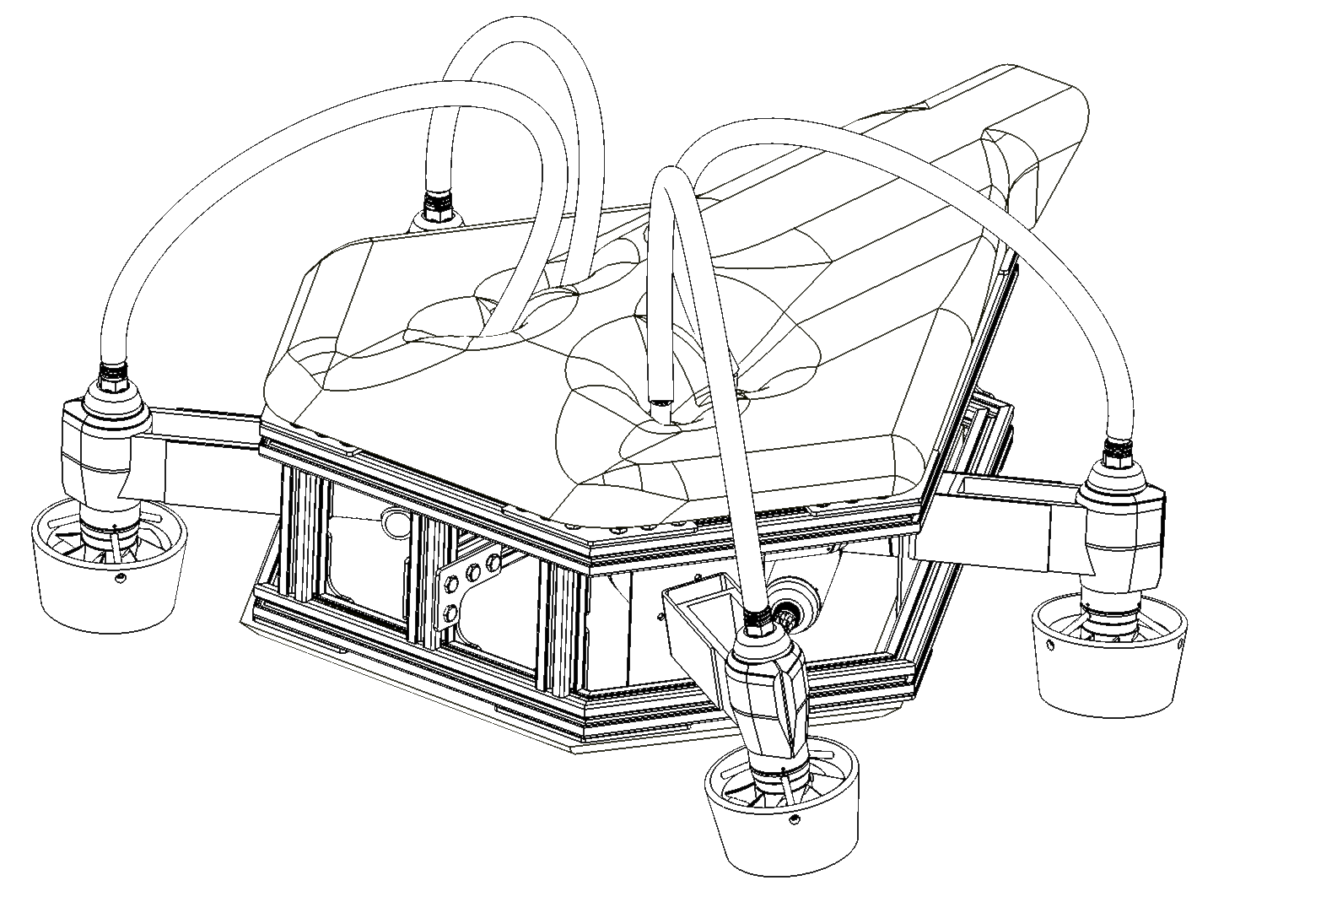

**Figure 5.** The mid-semester model of the ROV (team-fig)

The next and final improvement on the design came with the skin panels on the sides, top, and bottom. The skin panels protected the important electrical components inside the ROV and the syntactic foam from being damaged. The panels also prevented fish and other sea creatures from getting inside the ROV and affecting the operations of the ROV. The panels also provided a rigid body for water to flow around, instead of having the turbulent water from the thruster flow through the ROV, thus improving the hydrodynamics of the ROV. This design also came with a slight modification to the design of the syntactic foam because the introduction of the skin panels and an atmospheric pressurized vessel for the electronics affected the wet weight of the ROV. The dry weight for this final version of the ROV was 72.4 pounds, while the wet weight was 2.9 pounds. The skins on the side of the ROV allowed for optimal flow of water through the thrusters while decreasing the effects of propwash between the thrusters and providing protection to the electronics and syntactic foam to prevent damage.

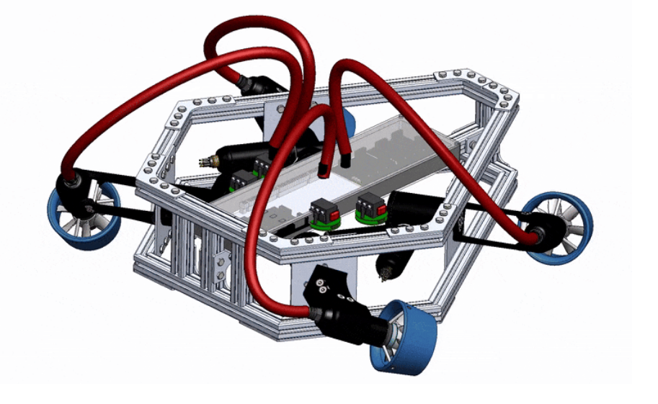

**Figure 6.** The final design of the ROV without the syntactic foam (team-fig)

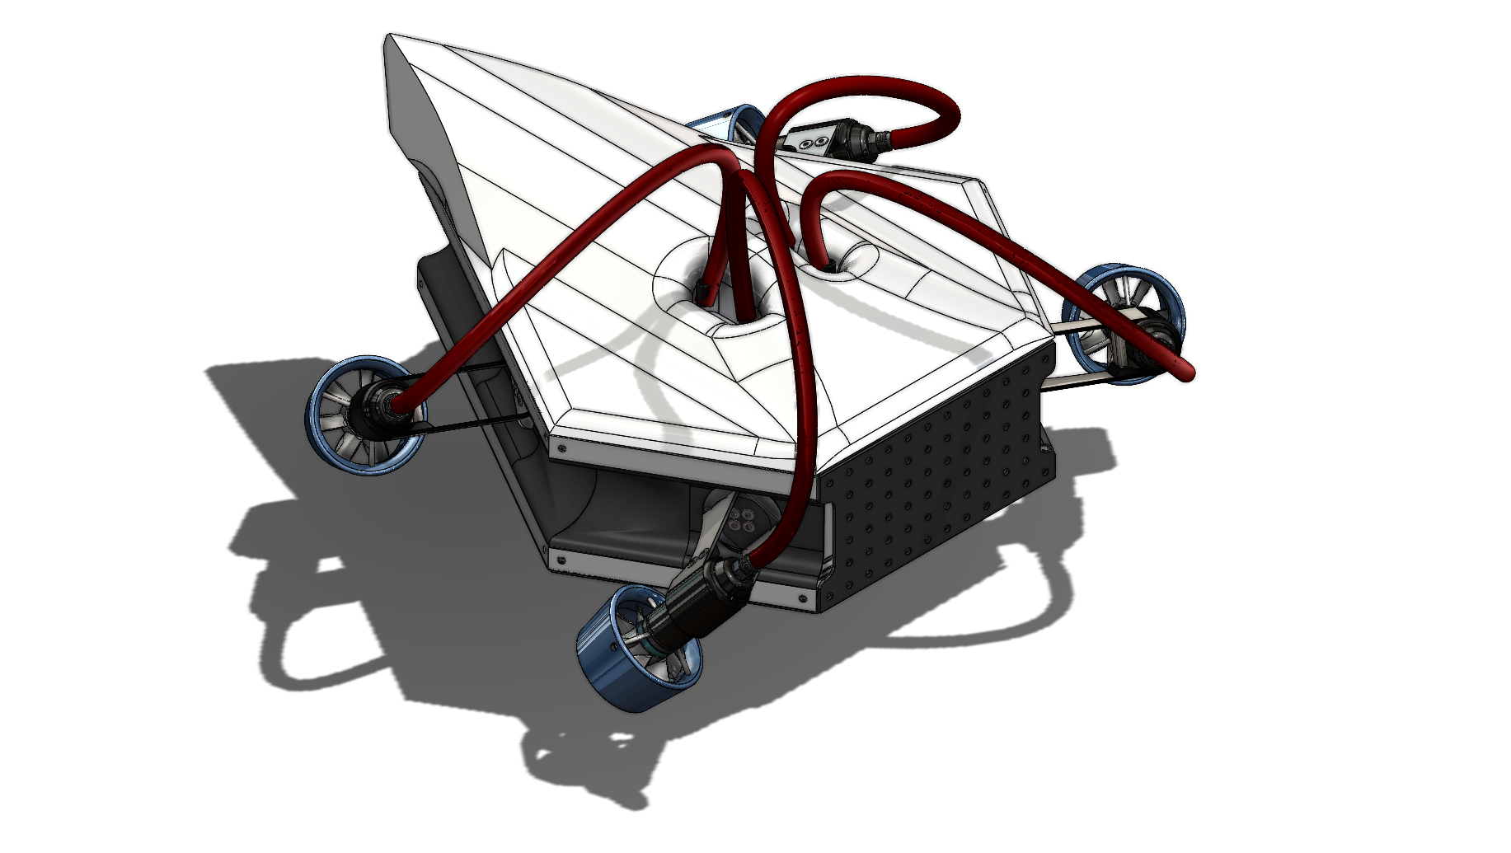

**Figure 7.** The final design of the ROV with the syntactic foam (team-fig)

# Detailed Design Overall System

This section details the chain of interfacing design elements that will result in a product that completes defined function requirements. These tools lay out the path of travel from power and/or operator input to output by the design prototype. This is an opportune way to understand how the product was designed and what components are responsible for intermediate functions, multiple functions, and how key design requirements had to be revised since brainstorming and proof of concept. This is a relevant mindset for this project in particular as this stage of the ROV design contained chassis and propulsion system design aspects.

This next-generation ROV’s unique thruster capability and optimized shape is shown through detailed design diagrams to have important relationships, while still maintaining numerous independent design elements. For example, the functional flow diagram shows that the camera system will relay information through the electronics and allow the operator to take advantage of the more convenient chassis shape and thruster-provided degrees of freedom.

## **Functional Diagrams**

These diagrams display the functional “path” of the design. Via the design requirements, projects are designed with the end operations in mind, and by understanding the components involved and how they interact with one another, a sort of roadmap can be created to flow through the interfaces from inputs to outputs, with outputs being the aforementioned design requirements. In the case of the ROV, this will mainly pertain to the mobility of the ROV being provided through the thrusters via electrical power, with the chassis holding everything steady.

### Functional Analysis Diagrams (FAD)/Functional Flow Diagram (FFD)

The functional analysis diagram is the roadmap from operator inputs to ROV motion and vision. This diagram outlines the ROV’s design capabilities from the point that the operator inputs a command based on their senses via the cameras that will be integrated into the ROV. This operator input is transmitted to the ROV’s electronic systems via the tether. The electronic systems control the cameras, rotary actuators, manipulators, and thrusters, which will allow these subsystems to function as intended. The chassis provides structural support and protection for these components by being designed such that the frame takes the force of the impacts, and the skin prevents rocks and fish from damaging the electronics. The thrusters provide movement to the ROV via the propellers, however, the water can also move the ROV through currents that must be taken into account.

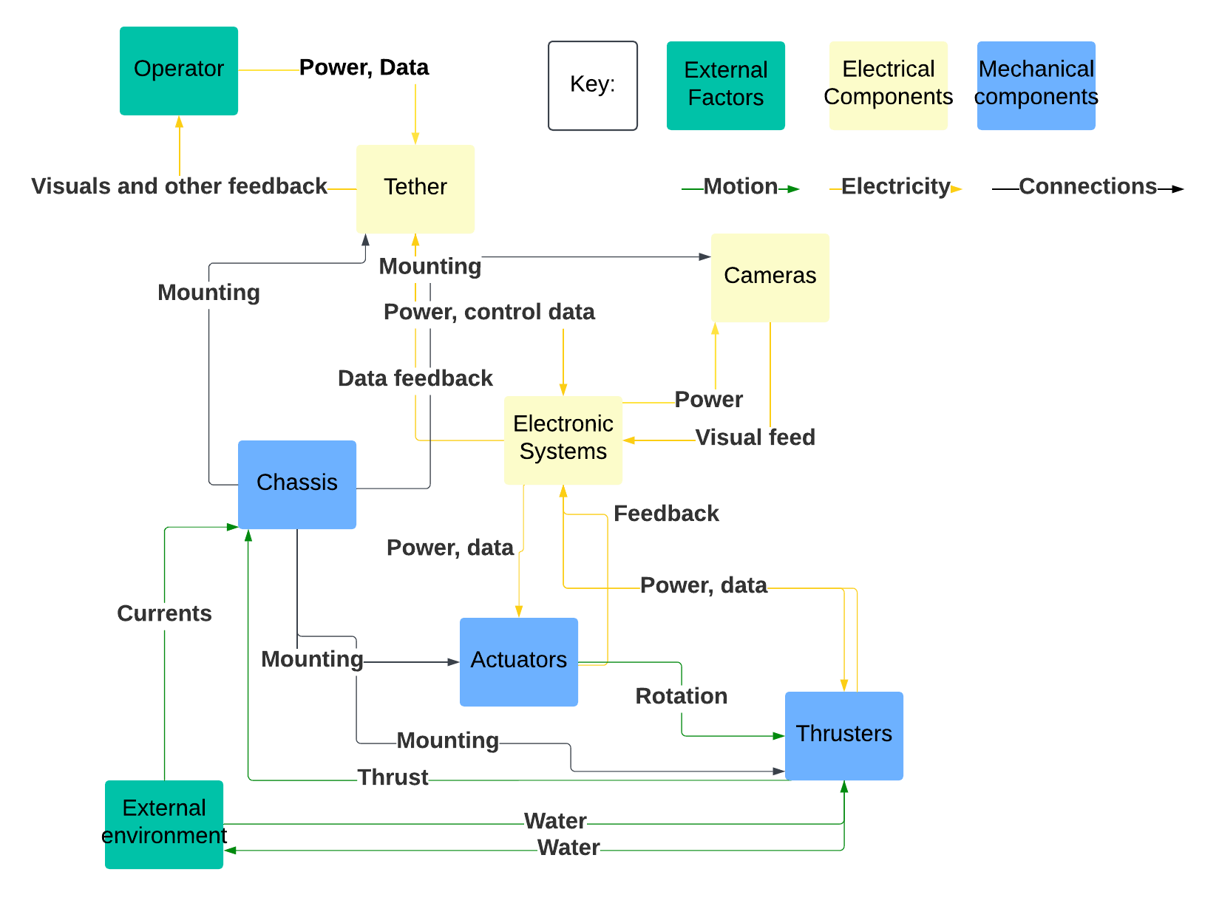

**Figure 8.** Functional Analysis Diagram for the subsea ROV. (team-fig)

## Physical Layout Diagrams

Chassis and propulsion layout:

The chassis and propulsion layout is shown below in **Figure 9 & 10**. This shows the locations of the syntactic foam, electronics, frame, rotary actuators, thrusters, and skin about each other. The syntactic foam is on both the bottom and top to provide buoyancy to the ROV. The electronics are encased in an atmospheric pressure vessel full of air so the electronics can function underwater. The frame is constructed out of aluminum bars and sheet metal, and stainless steel bolts and fasteners. The rotary actuators and thrusters come from Tecnadyne, both of which are full-depth rated (11,000 meters). Lastly, the skin is made out of ABS plastic which would be vacuum-formed using molds to protect the ROV.

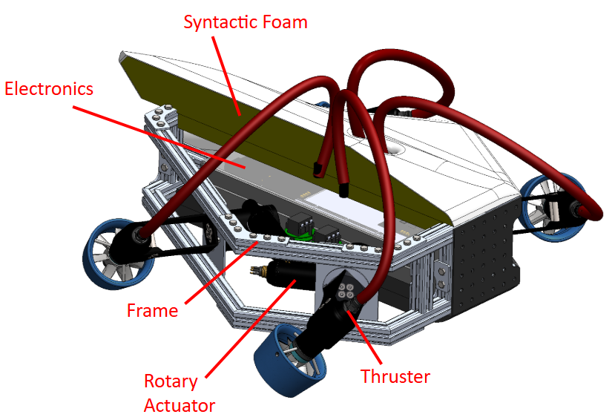

**Figure 9.** Physical layout of the chassis and propulsion subsystems (team-fig)

Electronic wiring diagram:

This wiring diagram was provided by Tecnadyne, as they provide the parts necessary for the power system with a predefined way of connecting them.

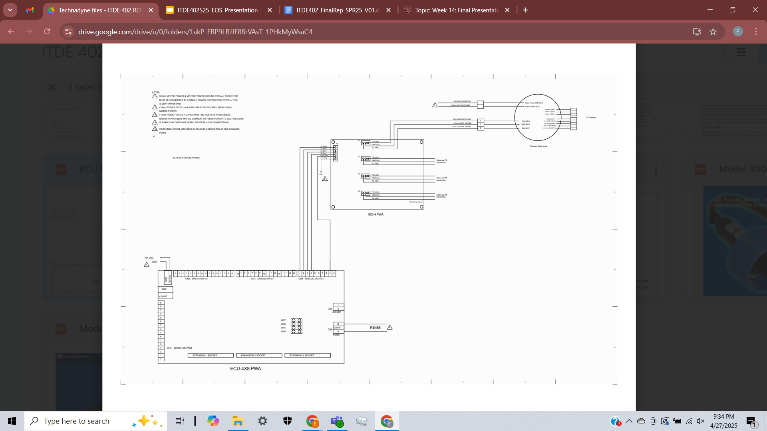

**Figure 10.** Wiring diagram for the thruster power and control system provided by Tecnadyne. Enlarged model is included in **Figure E.1.** in the appendix. (Tecnadyne)

The power subsystem, excluding components that only are used to affect the control voltage, properly begins at the ISO-4 card and continues to the thruster electronics module and into the thruster itself (not shown).

The ISO-4 circuit boards take in a 12V DC instrumentation power signal and four +/- 5V control signals, and outputs four isolated sets of 12V instrumentation power and a +/- 5V control signal. These signals are what is passed into the thruster electronics module and from there into the thruster.

The thruster electronics module takes in the signals from the ISO-4 circuit board as well as a separate, isolated 300V power source, conditions these signals, and passes them to the thruster.

The separate circuit board that is not part of the power system is an ECU 4x8 BIOS, which takes in computer commands and outputs a corresponding control signal voltage between -5 and +5 volts.

## Geometric Layout

## 

The Subsea ROV capstone project for the 2024-2025 school year consisted of chassis and propulsion design engineering. The geometric layout will provide diagrams and point out the key components of said chassis and propulsion components that were designed to meet the client's specifications for the next-generation ROV design prompt. Provided are cutaway views as well as exploded models to better understand the ROV and the interfacing of the components, as this is a key part of the 2 overarching design areas. The chassis was designed with the intention of providing a diver-like shape that will be noticeable in use, but also to receive the thruster system that will constitute the execution of free movement in all 6 degrees of freedom as one would be capable of doing were they underwater.



**Figure 11.** Internal view of the ROV showing the electronics, syntactic foam, frame, rotary actuators, and thruster. (team-fig)

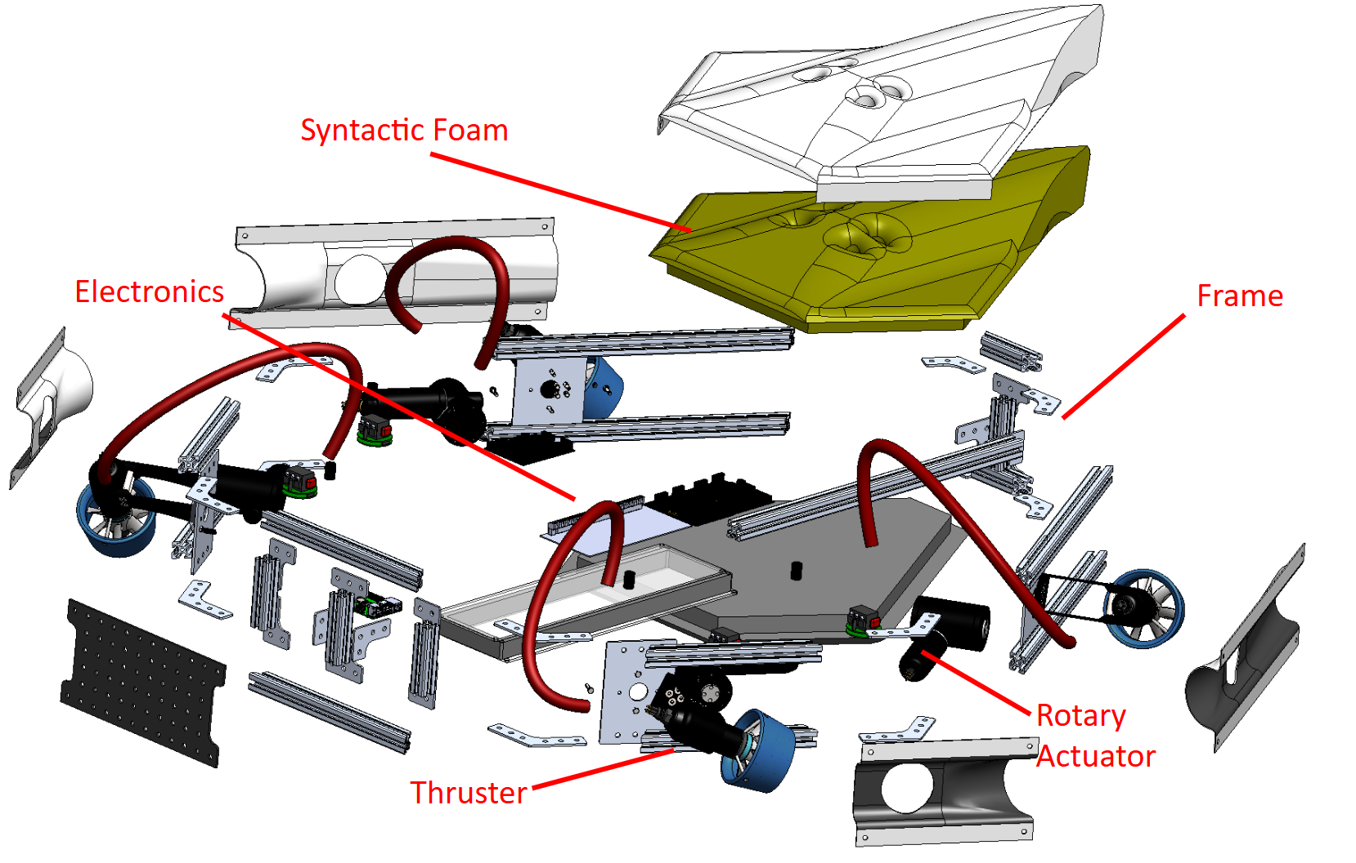

**Figure 12.** Exploded view of the ROV showing the key components of this phase of the design project. (team-fig)

The ROV model displayed above is the final iteration of the design. The ability to see the final shape of the constructed prototype as well as the inside of the top and side skin panels connects the dots between the overall shape and components. The skin gives way to the frame, designed with the previous team’s coffin shape in mind but now optimized to provide structural rigidity and be easily scalable to accommodate the growing amount of centrally-placed electronic components that will power systems in the future. The frame is intended to provide a hydrodynamically advantageous shape of a human torso when submerged, emphasized by the smooth, curvaceous skin panels. The inside of the ROV is available to future teams for power components, control system electronics such as rotary actuators, and the syntactic foam that will be calibrated to provide near-neutral buoyancy. The thrusters are placed between the angled sections of the frame on the port and starboard faces. This placement is strategic to the 6 degree of freedom design goal. The free rotation that will be provided by the rotary actuators will allow for the thrusters’ angles of orientation to allow a force vector in any direction, allowing the operator to move freely without limitation or the necessity of calculating every adjustment based on the limited mobility of the ROV.

## Bill of Materials

**Table 2.** Bill of materials for the prototype (team-fig)

| **Item No.** | **Sub System description** | **Part Specs** | **Description** | **Cost Per Unit** | **Quantity** | **Total Cost** |
| --- | --- | --- | --- | --- | --- | --- |
| 1 | Extruded Aluminum Bars | 1”x3’, solid, smooth finish | Aluminum bars serve as light but rigid frame sections. Extruded quality will allow for effective component mounting and allow adjustments. | $15.90 | 7 | $110 |
| 2 | Sheet Aluminum 5052 | 1/8”, 24” x 24” | One sheet of specified grade aluminum; is used to supply frame connecting brackets, as well as thruster mounting hardware. | $99.06 | 1 | $100 |
| 3 | Stainless Steel Extrusion Nuts | 1/4”-20 | Specialized fasteners to accommodate the extruded aluminum frame. | $9.13 per 10 | 15 | $137 |
| 4 | 316 Stainless Steel Hex Head Screw | 1/4”-20, 3/8” | The screws that will be used to fasten the frame sections and brackets together. Specific sizes were needed to accommodate the gap in the aluminum bars and the thread specifications of the nuts. | $5.38 per 25 | 6 | $32 |
| 5 | 316 Stainless Steel Hex Head Screw | 10-32, 3/4” | These screws are used to fasten frame components and thruster mounting hardware together and to the frame. | $4.80 per 10 | 2 | $10 |
| 6 | 316 Stainless Steel Hex Head Screw | 1/4”-28, 3/4”, 82° countersink | The countersink screws are used to secure the rotating thruster mounting brackets to the vertical plates attached to the frame. There are 4 per thruster. | $3.84 per 5 | 7 | $27 |
| 7 | 316 Stainless Steel Round Coupling Nut | 1/4”-28, 1-1/4” | The coupling nuts are hollow cylindrical threaded fasteners to be placed between the bent plates of the thruster mounting arms and the printed thruster clamp to create the clamping force upon the thrusters | $10.97 | 8 | $90 |
| 8 | ABS Sheet | 36" x 36" x 1/16" | This sheet of basic plastic will be used to form the preliminary skin model shape | $35.71 | 4 | $145 |
| 9 | Tecnadyne Model 300 Thrusters | 475W  17 lbf forward thrust / 7 lbf reverse thrust  2.8-3.1 lbs or 1.8-2.8 lbs (submerged) depending on the configuration  2,800ft (850m) depth rating | Thrusters capable of providing forward and reverse thrust at the desired quantity to move the ROV with precision and efficiency without being difficult to control. Capable of running at various voltage levels and with adjustable analog speed. The thrusters are rated at appropriate depths of current industry offshore rigging. The thrusters are generously donated by sponsors but are mounted without power to the ROV due to difficulty acquiring a sufficient source to power them. | $7,500 | 4 | $30,000 |
| 10 | Tecnadyne Model 20W Rotary Actuators | 150-300W  Output speeds of 1.5 RPM to 45 RPM  20 ft-lb of tq  2.5-5 lbs or 1.6-3.2 lbs (submerged) depending on the configuration  Full depth rated | Rotary actuators are intended to provide the amount of force and responsiveness to orient the thrusters as we imagined. Variable output speed and adjustable analog speed allow for good useability. Lightweight and with depth rating as a non-issue, the actuators will be a key component in the ROV’s functionality. Due to the heavy expense, physical ones are not present in the prototype. | $12,500 | 4 | $50,000 |
| 11 | Insta360 X3 CINSAAQ | 360 degree 5.7k footage  lightly waterproofed  Active HDR  Flowstate stabilization | The cameras that will be used in the 360-degree vision capabilities that the ROV is intended to provide. Advanced stabilization and HDR features will render more precise imaging. They will be mounted around the ROV and interfaced with each other as well as a VR headset that will allow the operator to work as if their head is where the ROV is. This model is not a definitive choice, as they are not fully waterproof. | $329.99 | 3 | $990 |
|  | | | | | **Total** | **$81,640** |

## Estimated Cost for Prototype

The estimated cost for the prototype was calculated by referencing the cost of parts already purchased, and the estimated cost of parts quoted and unobtained. The off-the-shelf parts include all parts, such as the fasteners, screws, ABS and aluminum sheets, aluminum bars, and 360-degree cameras, ordered by this team and the previous teams, as well as all donated parts. The 3D-printed parts were used for the modeled skin panels and thruster clamps. There was no off-campus production used in the production of the ROV. The TBD expenses include the rotary actuators, syntactic foam, and an estimate for the expense of the following years. Lastly, the consulting expenses come from the cost to Oceaneering International for their consultation with the team, as well as other consults with the FEDC and the Zachar Common Labs.

**Table 3.** Cost estimate table for the project

| **Expense Type** | **Items** | **Description** | **Total Cost** |
| --- | --- | --- | --- |
| Off The Shelf | Fasteners, frame & propulsion system material, skin panel material, thrusters | All the materials were bought to construct the chassis frame, skin panels, and thruster mounting components. The thrusters are available from Tecnadyne to purchase. | $31,426.28 |
| 3D Printed | Skin panels, thruster clamps | The clamps that the thruster housing slides into as well as the production of the skin panels using the purchased material | $40 |
| Off-Campus Production | N/A | N/A | N/A |
| TBD Expenses | General electronics, buoyancy material, systems interfacing, tether accommodation | Any parts of the project phases to come. Primarily the systems integration, controls, and further mechanical engineering necessities. | $65,000 |
| Consulting | Marine and petroleum engineering consulting | Necessary to design a system with awareness of proper marinization and equipment for use around rigging equipment. | $20,000 |
|  |  | Total | $116,466.28 |

# Detailed Design: Engineering Analysis

During the engineering analysis phase of the design, the team looked at two different

The first use of engineering analysis to the ROV was to determine the ROVs weight in water, or wet weight with syntactic foam. This was an important engineering specification, so the ROV would stay steady in water with little or no force from the thrusters. The goal was to be neutrally buoyant with a tolerance of at most 4 pounds on either side of neutrally buoyant.

Using the detailed CAD model, the overall mass and volume of the ROV was calculated. Using the volume, the team was able to calculate the amount of water displaced by the ROV, which was used to find the buoyant force acting on the ROV. By subtracting the buoyant force from the force of gravity, the team was able to determine the ROVs weight in water. To perform the analysis, the team assumed there were no air pockets in the ROV that were not intentionally put there. In the real ROV, these air pockets would displace more water than was originally counted for, decreasing the ROVs wet weight.

Using the CAD model, the team was able to determine that the dry weight of the ROV was 72.4 pounds and took up a volume of 1,923.5 cubic inches. In sea water, this displaces 69.5 pounds of water. Using Archimedes’ Principle, the ROV design had a wet weight of 2.9 pounds.

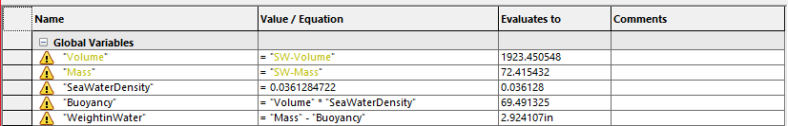

**Figure 13.** Calculations of Archimedes’ Principle in SolidWorks. (team-fig)

This value fits within the team's tolerance of 4 pounds. A weight of 2.9 pounds means the ROV will naturally sink. If power to the ROV is cut, this means the ROV will sink to the ocean floor where it can easily be found and recovered. However, this means all parts on the ROV must be full depth rated, otherwise the ROV could be destroyed if it sinks too deep.

The second use of engineering analysis to the ROV was to analyze the 6-degrees of freedom in the team’s ROV design. This was a very important customer specification as the ROV had to have the characteristics of a human diver.

Each of the four thrusters on the ROV had two variables, the thruster’s rotational position and the thrusters power output, in pound force. Which led to a total of eight independent variables used for finding the overall velocity and rotation of the ROV. For this analysis, the water moving through the thruster was assumed to be laminar. This would not be the case in the real design, but was determined to be a reasonable approximation of the purposes of the engineering analysis. The distances to the center of the clamp holding the thruster were used to calculate the rotational torque vectors that the thrusters would apply to the system. The forces from each thruster were calculated using the rotational position of the thrusters and the geometric shape of the ROV.

Testing the number of degrees of freedom the ROV has was performed in Desmos and Excel by determining the net force and torque vectors given different power and direction inputs to the four thrusters. The Excel spreadsheet was utilized to calculate the resultant force and torque vectors given thruster positions and output forces. **Figure F.1.** shows the Excel spreadsheet and the resultant forces and torques when all four thrusters are pointing forward and outputting 1 lbf of thrust. As can be seen from the spreadsheet, with all four thrusters pointing forward and outputting 1 lbf of forward thrust, the ROV has no rotational torques, no vertical or lateral forces, and 3.464 pounds of force acting in the longitudinal direction. With a slightly negatively buoyant ROV, 2.9 pounds in water, this provides an acceleration force of 1.2 ft/s^2, excluding the resistance due to water.

# “The Build” -Fabrication/Construction/Production/Synthesis/Coding

The build was completed in four primary stages: frame construction, thruster arm construction, skin construction, and electrical connection. Each of these phases had several sub-sections and multiple component parts, often necessitating multiple trips to the FEDC. Each of these phases will be separately discussed and the steps outlined.

## Stage 1: Frame Construction

The frame construction was the most complex and labor-intensive part of this build. The first step of this stage was creating the required bars and brackets from the stock aluminum bars and sheets. The brackets were cut out by FEDC staff using a CNC machine, while the aluminum bars were cut to the proper lengths and angles by team members using an FEDC chop saw. The edges of these cuts were then filed for smoothness and safety.

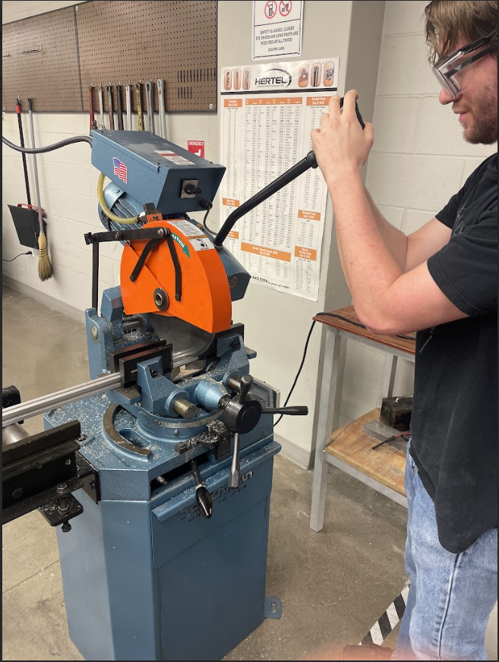

**Figure 14.** A team member cuts an aluminum bar using an FEDC chop saw. (team-fig)

After the parts were properly cut out and the fasteners were obtained, the bars and brackets were screwed together. The fasteners were larger than expected, and some of them did not fit in the places they were assigned in the CAD. This tolerance issue was solved by selectively sourcing fasteners that matched the required dimensions in the CAD file. The fasteners that could not be selectively sourced were ground down to ensure their compatibility with the correctly sized fasteners.

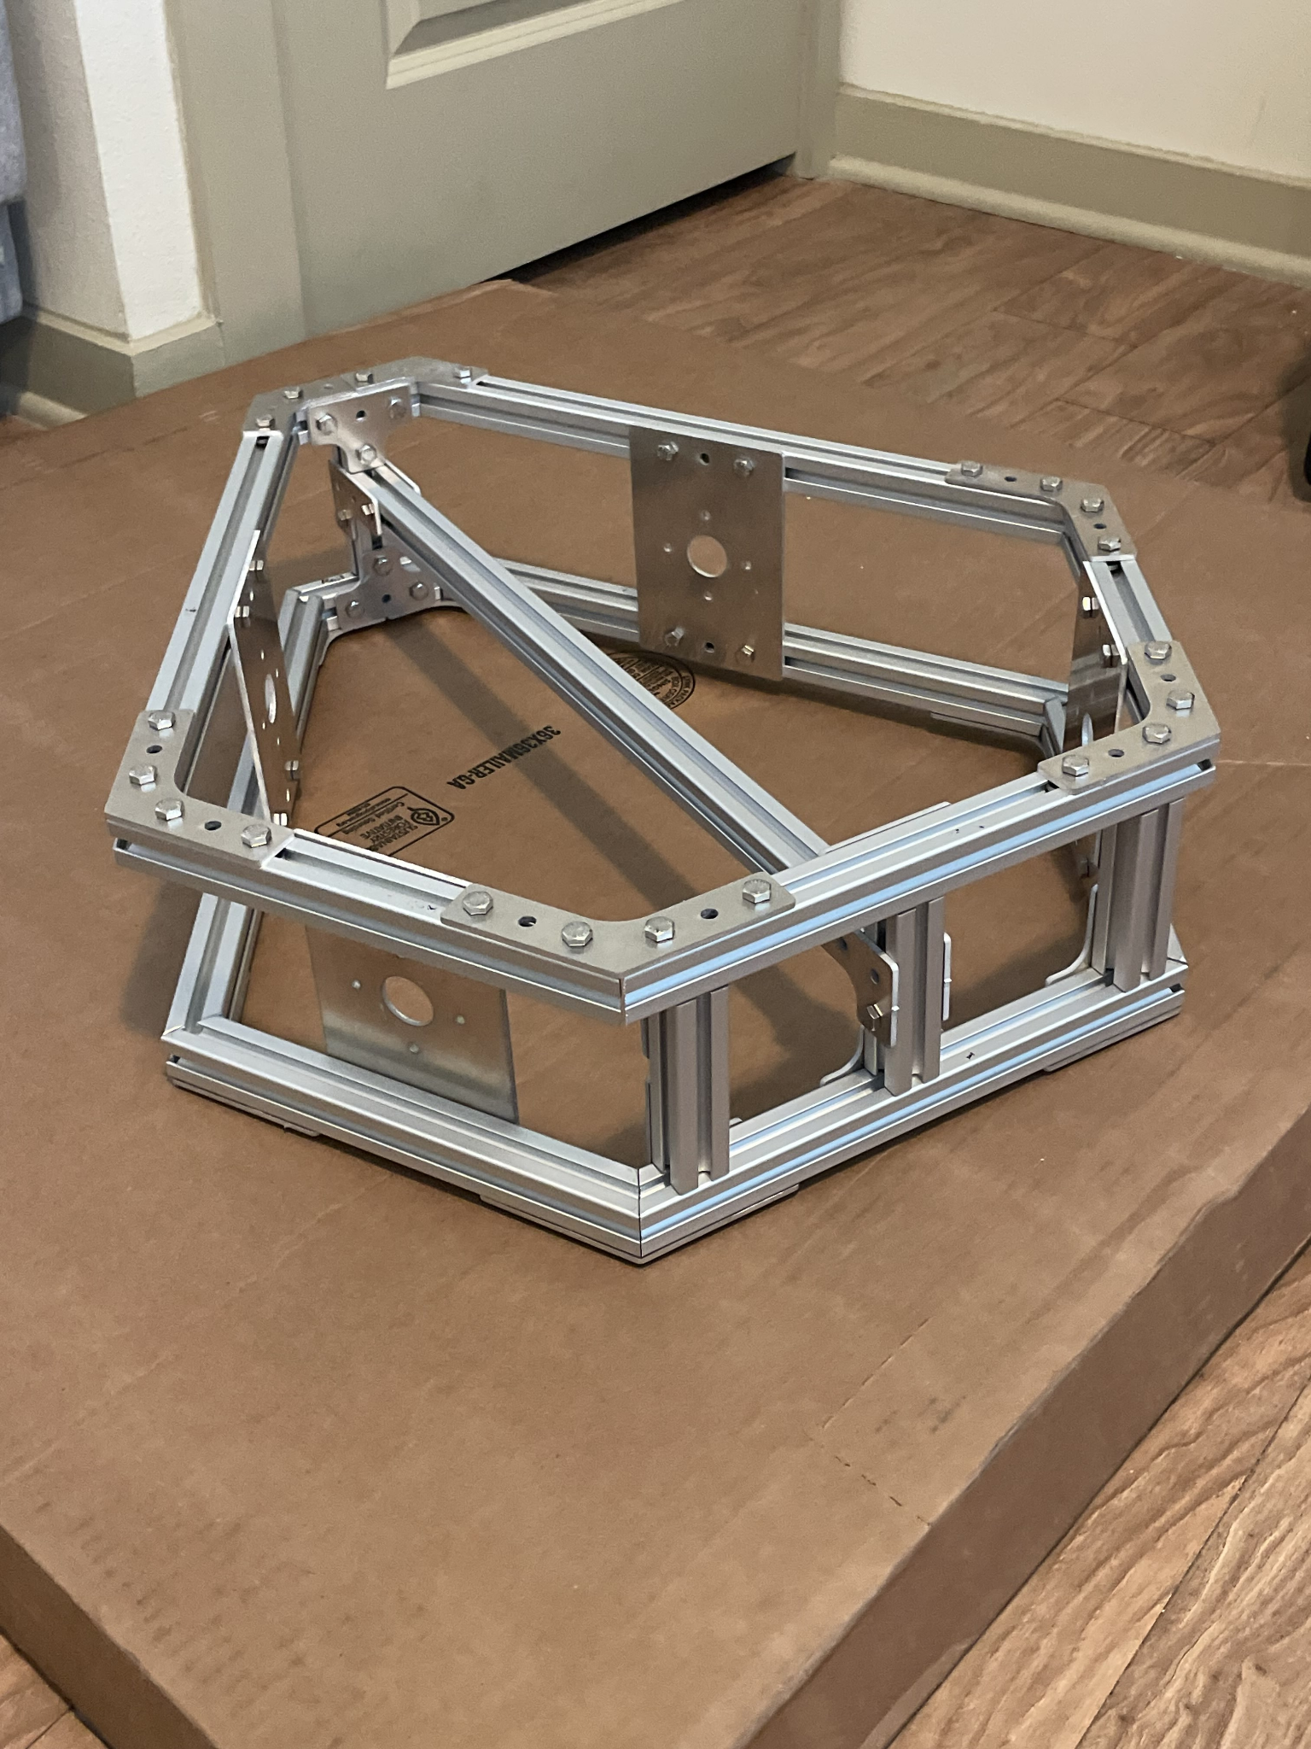

**Figure 15.** The completed aluminum frame of the chassis. (team-fig)

Tools used to complete the frame:

* 7/16” hex nut driver - used on the 1/4-20 x 3/8
* 5/16” hex nut driver - used on the 10/32 NF x 3/4
* 5/32” hex key - used on the 1/4-28 NF x 3/4
* Thin stick - used to position the End-Feed T-Slotted Framing Fasteners inside the T-Slotted Frame

## Stage 2: Thruster Arm Construction

The thruster arms were constructed from 3 primary parts: an aluminum arm, a 3D-printed thruster clamp, two fasteners, and 3 (parts for allowing rotation). Each aluminum arm was first cut out by FEDC staff using a CNC machine and then bent into the proper shape by a team member at the FEDC. The thruster clamps were 3D-printed using a team member’s 3D printer, as were the (parts for allowing rotation). Each arm was then attached to the aluminum plates on the sides of the frame using additional screws and fasteners.

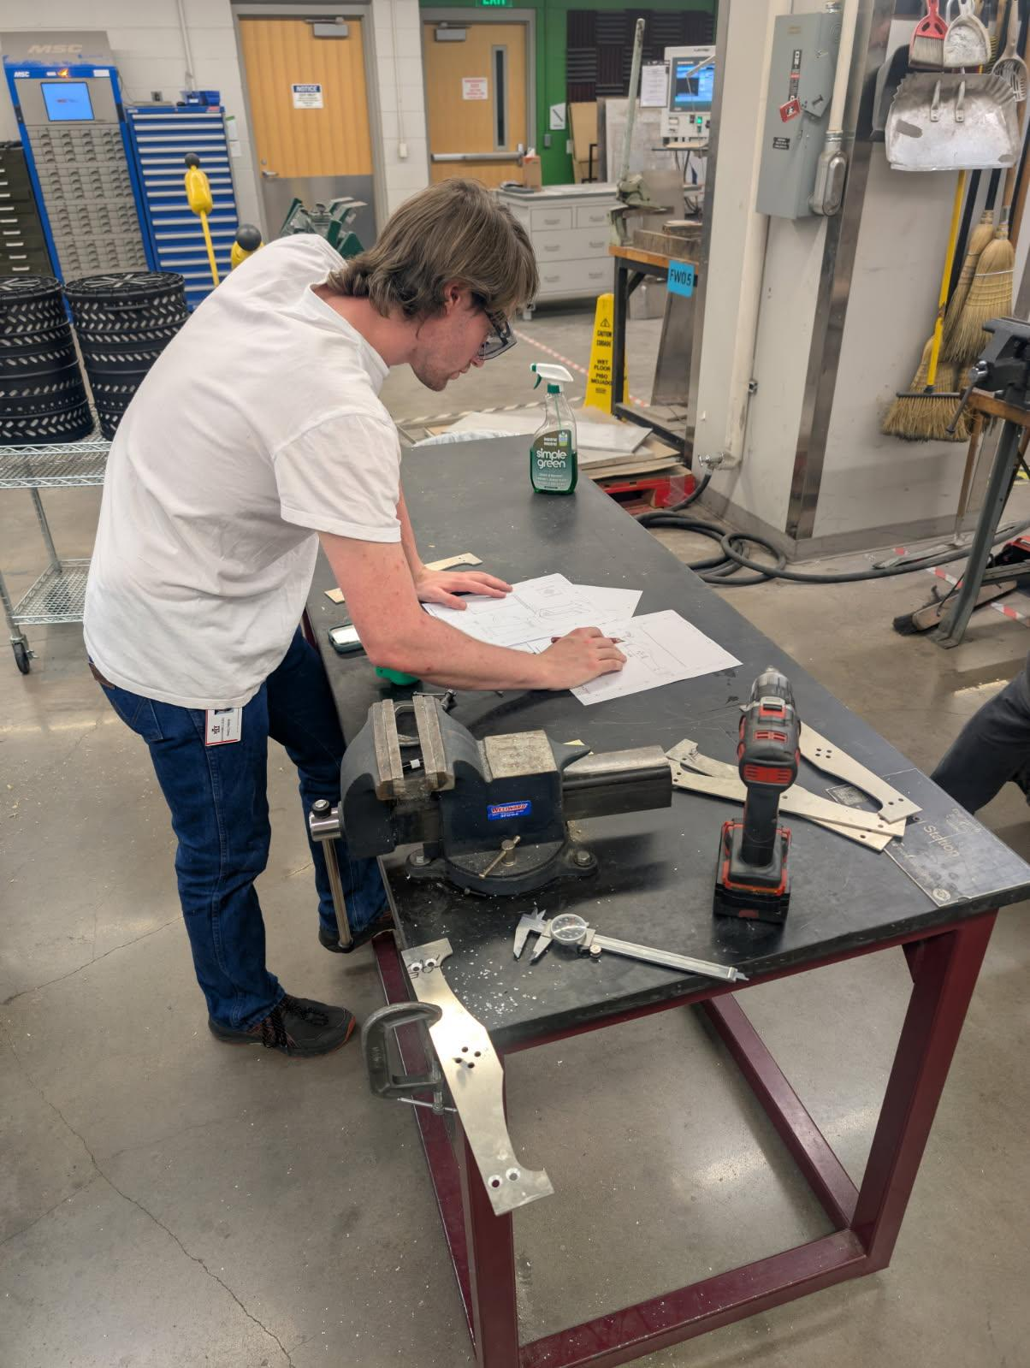

**Figure 16.** A team member prepares to bend the aluminum section of the thruster arms. (team-fig)

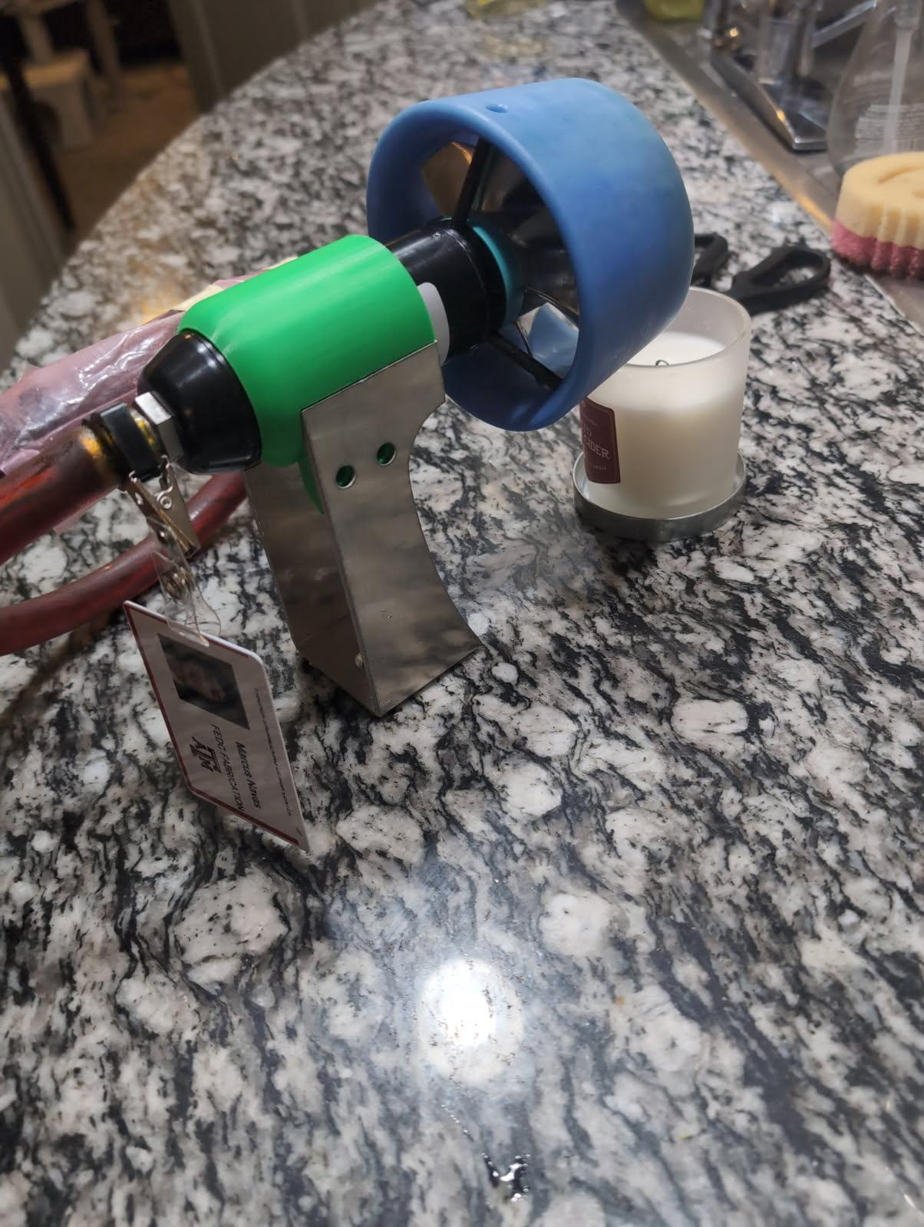

**Figure 17.** A thruster sitting in the thruster clamp and aluminum arm. (team-fig)

The clamp model was 3D printed to determine its ease of manufacturability before being manufactured using HDPE. Part of the model was determined to be non-manufacturable and needed to be redesigned.

## Stage 3: Skin Construction

All the skin panels were 3D printed. The team wanted to test the overall design of the skin panels on the physical model before forming the real model. The team discovered that a clip on the thruster tube, which hadn’t been accounted for in the CAD model, made the gaps for the tubing too small. This oversight was accounted for in the most recent CAD designs that came after the prototype was fabricated. **Figure 18** shows the updated CAD model with space for the clips taken into account.



**Figure 18.** Top skin panel with space for the clips on the thruster tubing. (team-fig)

The side skin panels covering the front two thrusters were small enough to print as one piece, however, every other skin panel needed to be split into multiple pieces to fit in the 3D printer, requiring them to be glued together. The team obtained ABS plastic which the following team can use to create the final skin panels. The ABS plastic will be vacuum-formed using molds to shape the skin once the final design of the ROV has been determined by the following capstone teams.

There is no bottom skin panel in the prototype unlike in the CAD because, without the syntactic foam, the 3D-printed material would not be strong enough to hold up the ROV.

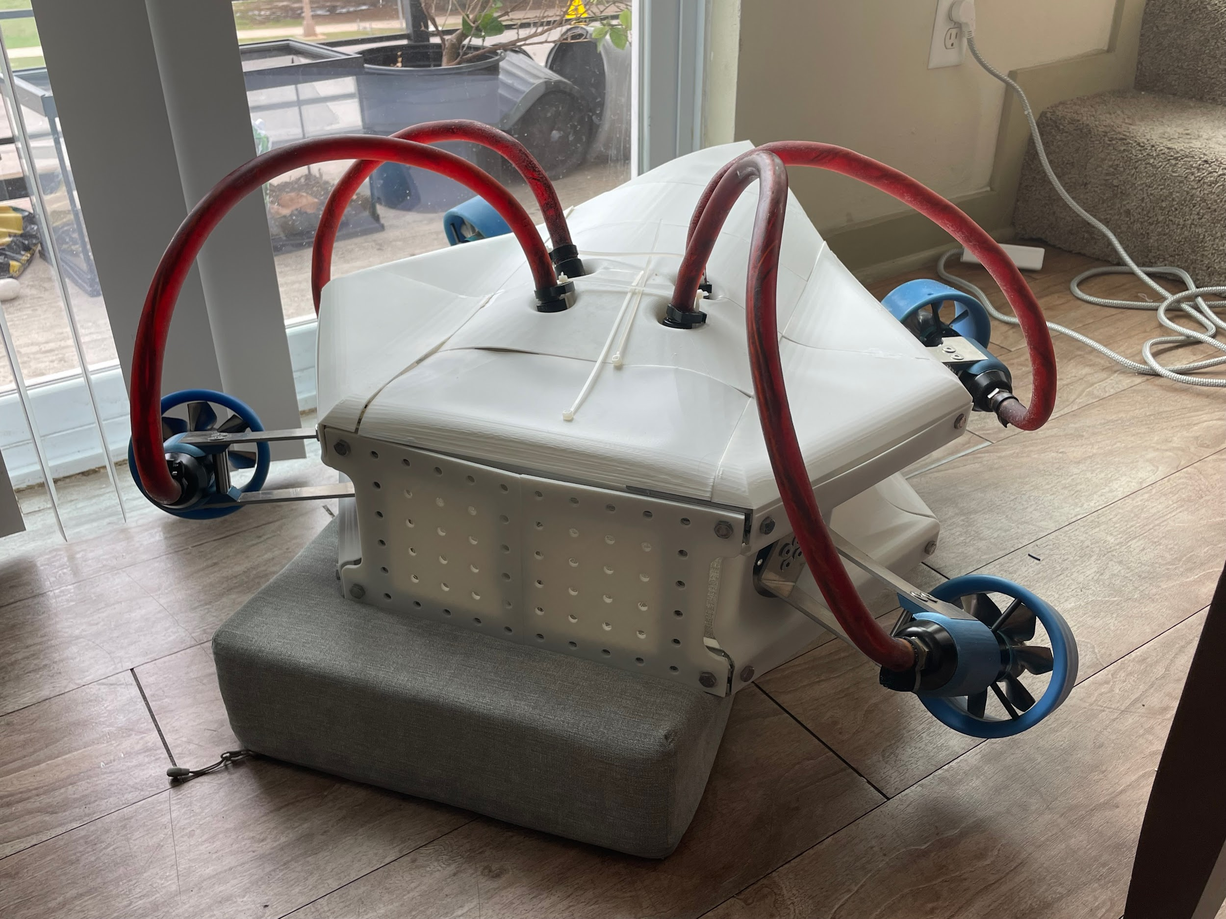

**Figure 19.** Port isometric view of the ROV with the skin panels (team-fig)

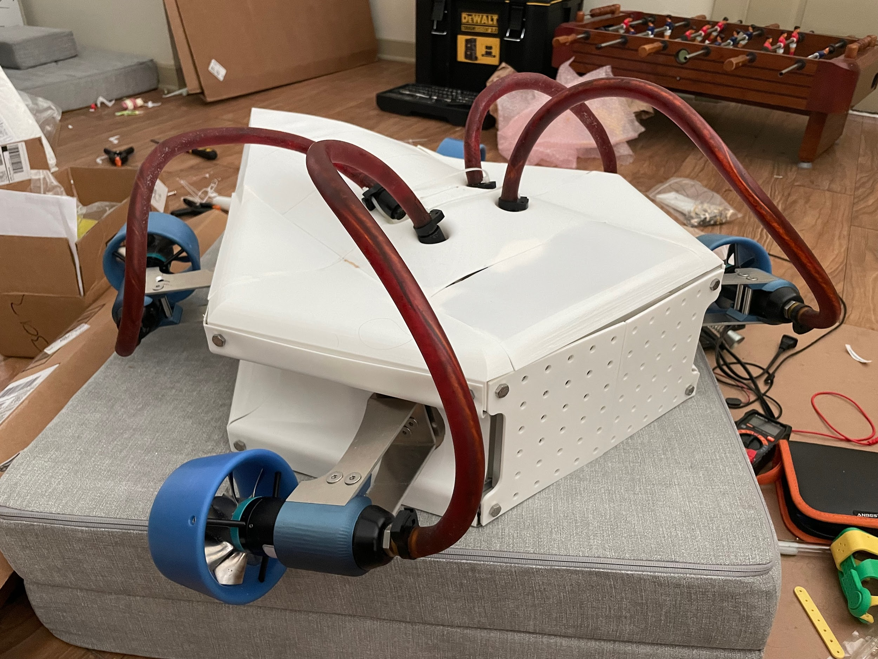

**Figure 20.** Starboard isometric view of the ROV with the skin panels (team-fig)

## Stage 4: Electrical Connection

The electrical connections were assembled in parallel and separately from the frame and chassis build. The build was conducted using the information in figure (#) provided by Tecnadyne. The actual build started from the ISO-4 card and connected it to one thruster electronics module and from there to the thruster itself. Some parts, like the ISO-4 card and the motor sensor connector, had standard connections that available wires could be attached to, while some connections required other techniques. Wires were looped around the pins for the control signal and soldered to the wires coming off the ISO-4 card, while the pins connected to the motor power section accepted a wire in between their halves. The cable attached to the thruster was the correct size for standard wires and solder to be connected. However, while the connections into the thruster would properly be soldered in the final product, they were not in this build since the thruster needed to be easily disconnected for verification of the function of the thruster arms.

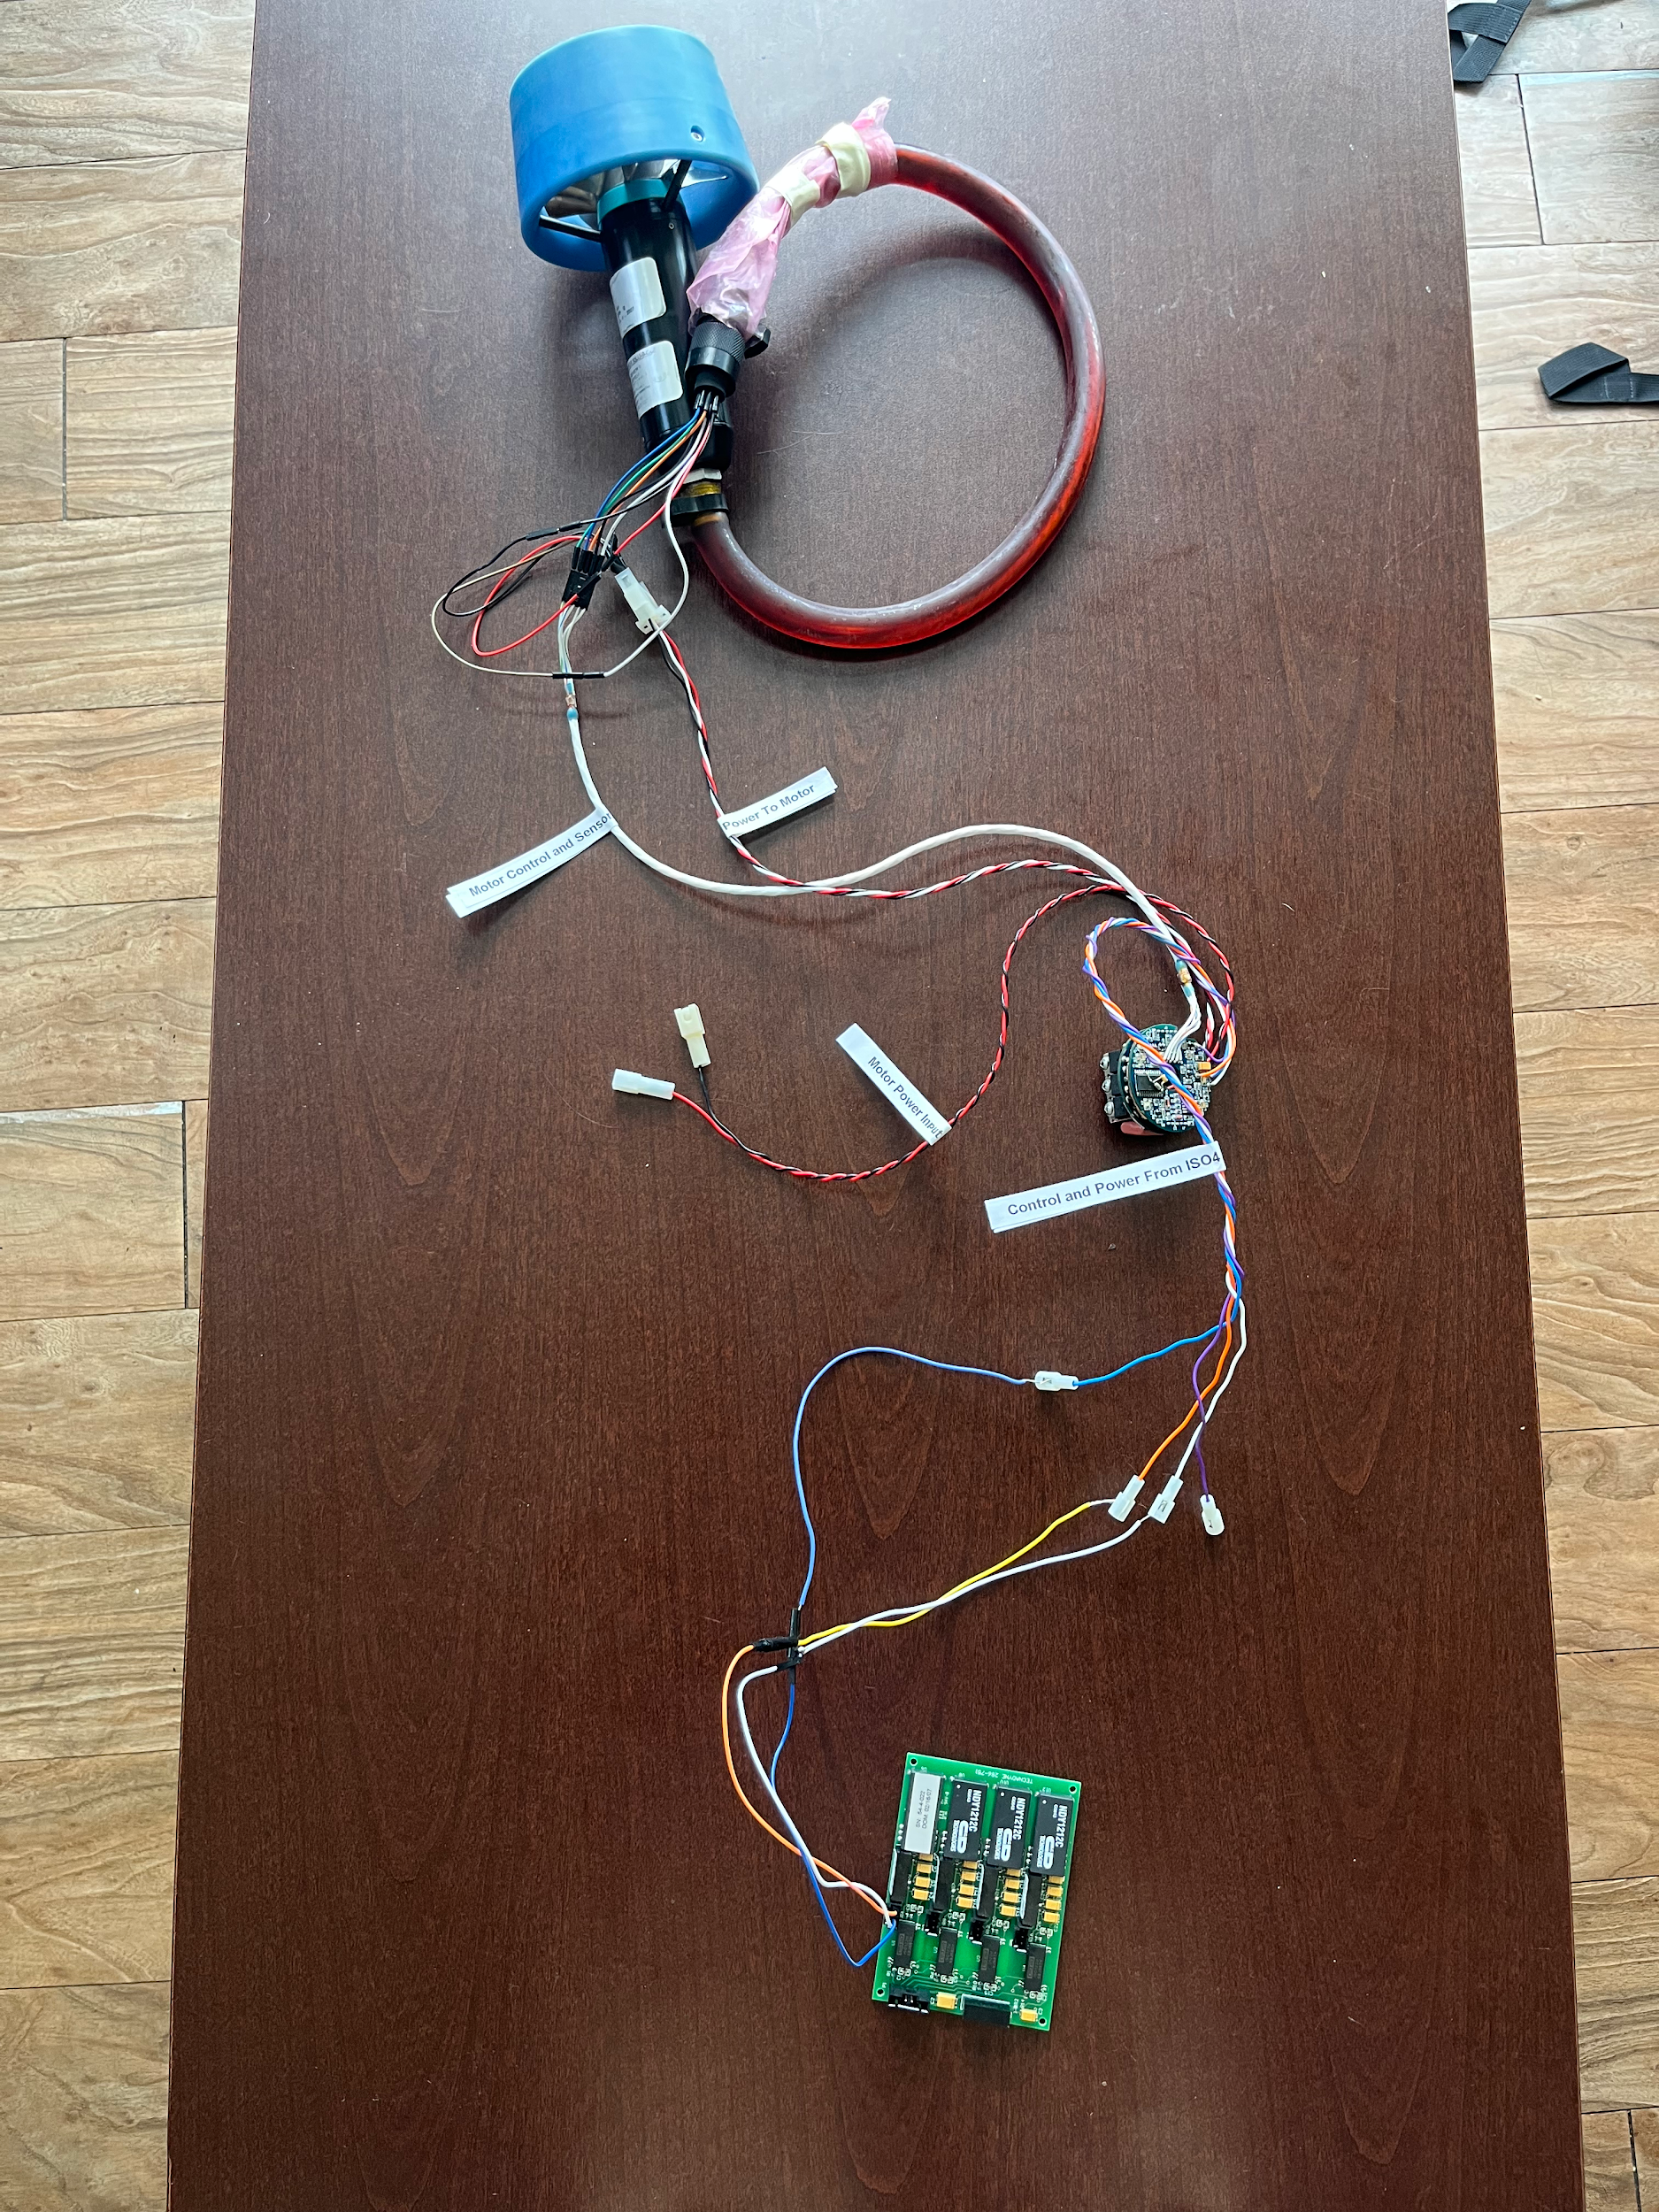

**Figure 21.** The wiring for the power subsystem is connected to the subsea thruster. (team-fig)

The electrical subsystem was not physically integrated into the model, despite having a space set aside in the CAD, because an atmospheric pressure vessel, or “bottle,” needs to be designed to properly hold the electronics. This is a matter for future teams.

# 

# 

# 

# Testing/Verifying/Validating/Experimental Plan

The three areas the team looked into for testing, verifying, and validating were the 6 degrees of freedom of the ROV, the overall strength of the ROV, and the power of the thrusters.

Testing the number of degrees of freedom the ROV has was performed in Desmos by determining the net force and torque vectors given different power and direction inputs to the four thrusters. An Excel spreadsheet was also utilized to calculate the resultant force and torque vectors given thruster positions and output forces. **Figure F.1.** shows the Excel spreadsheet and the resultant forces and torques when all four thrusters are pointing forward and outputting 1 lbf of thrust.

To test the strength of the build, the team simulated different forces in Solidworks. Because the CAD model had every fastener and bolt modeled, the simulations had to use a simplified model because there wasn’t enough memory in the computer to simulate the stresses in every bolt. **Figure 22** below shows the stress-strain curve of 5052 aluminum. The elastic region of 5052 aluminum ends at roughly 175 MPa, meaning the stresses in the CAD model must be below 175 MPa so the frame returns to its original shape.

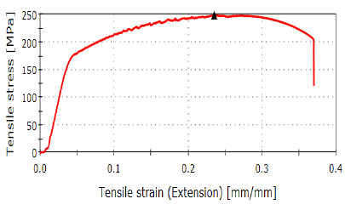

**Figure 22.** Stress/strain curve for 5052 Aluminum

**Figure 23** shows the heat map for a 50-pound force acting on the thruster clamp acting downward with the thruster arm horizontal. The ROV will rarely experience a 50-pound force in the perpendicular direction to the thruster arm. The only time this could happen is if the ROV impacts an external object. As can be seen by the legend bar on the right, the maximum stress experienced by the frame is 151 MPa, well below the 175 MPa limit. If the ROV impacts something that causes a greater than 50-pound force onto the thruster arm, the point of failure is the bolts connecting the thruster arm to the rotary actuators. These bolts would shear, preventing lasting damages from affecting the expensive thrusters or rotary actuators. If this were to occur, the thruster would be shut down and the ROV would return to the surface for repairs.

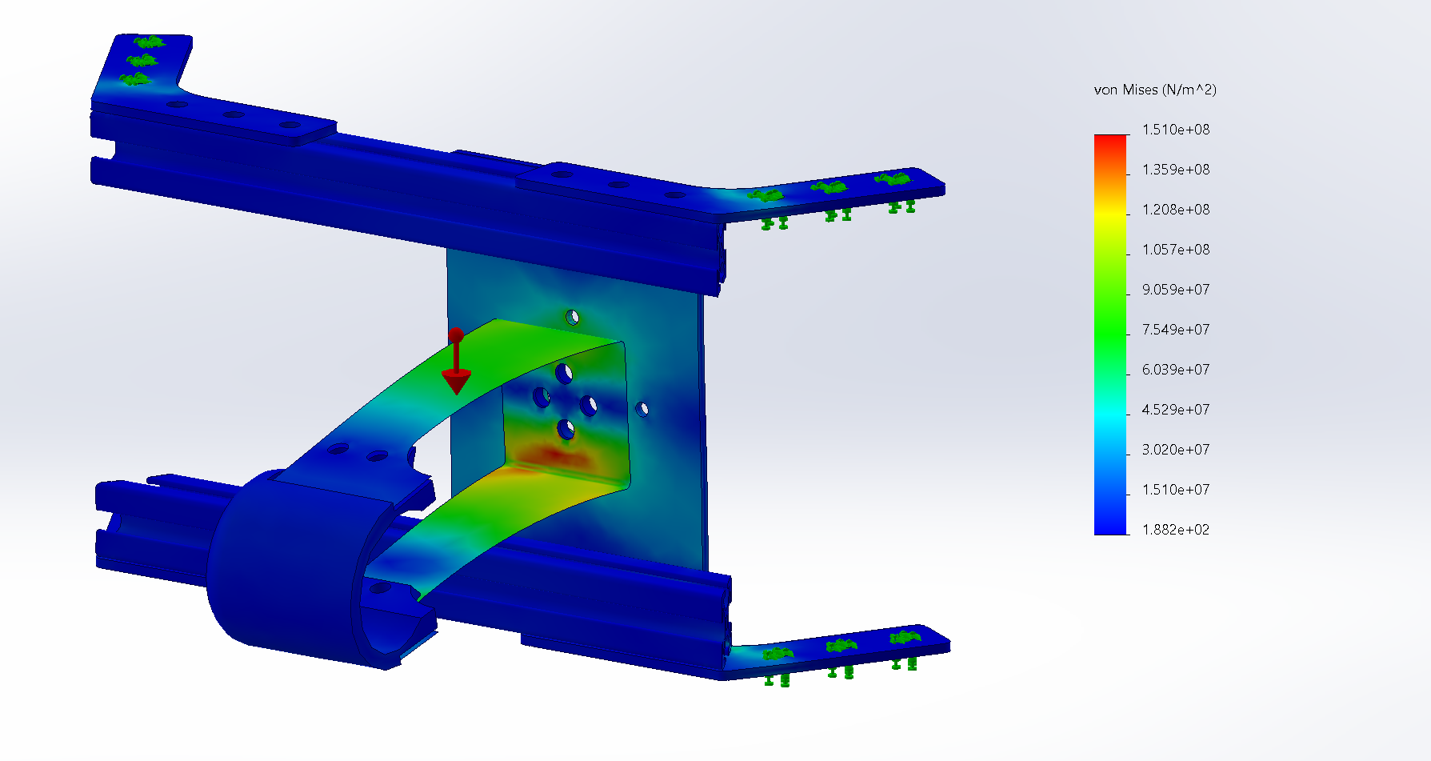

**Figure 23.** Stress heat map for a 50-pound force acting on the thruster clamp acting downward with the thruster arm horizontal (team-fig)

**Figure 24** shows the stress heat map for a 90-pound force acting on the thruster clamp acting downward with the thruster arm vertical. As can be seen from the heat map legend on the right, the highest stresses experienced by the ROV frame are in the 150 MPa range, which is less than the critical 175 MPa stress value. The thruster arm would experience this force when the thrusters are in reverse. The maximum force the thrusters can output in reverse is 8 pounds, meaning the frame and thruster arms are easily able to withstand that force.

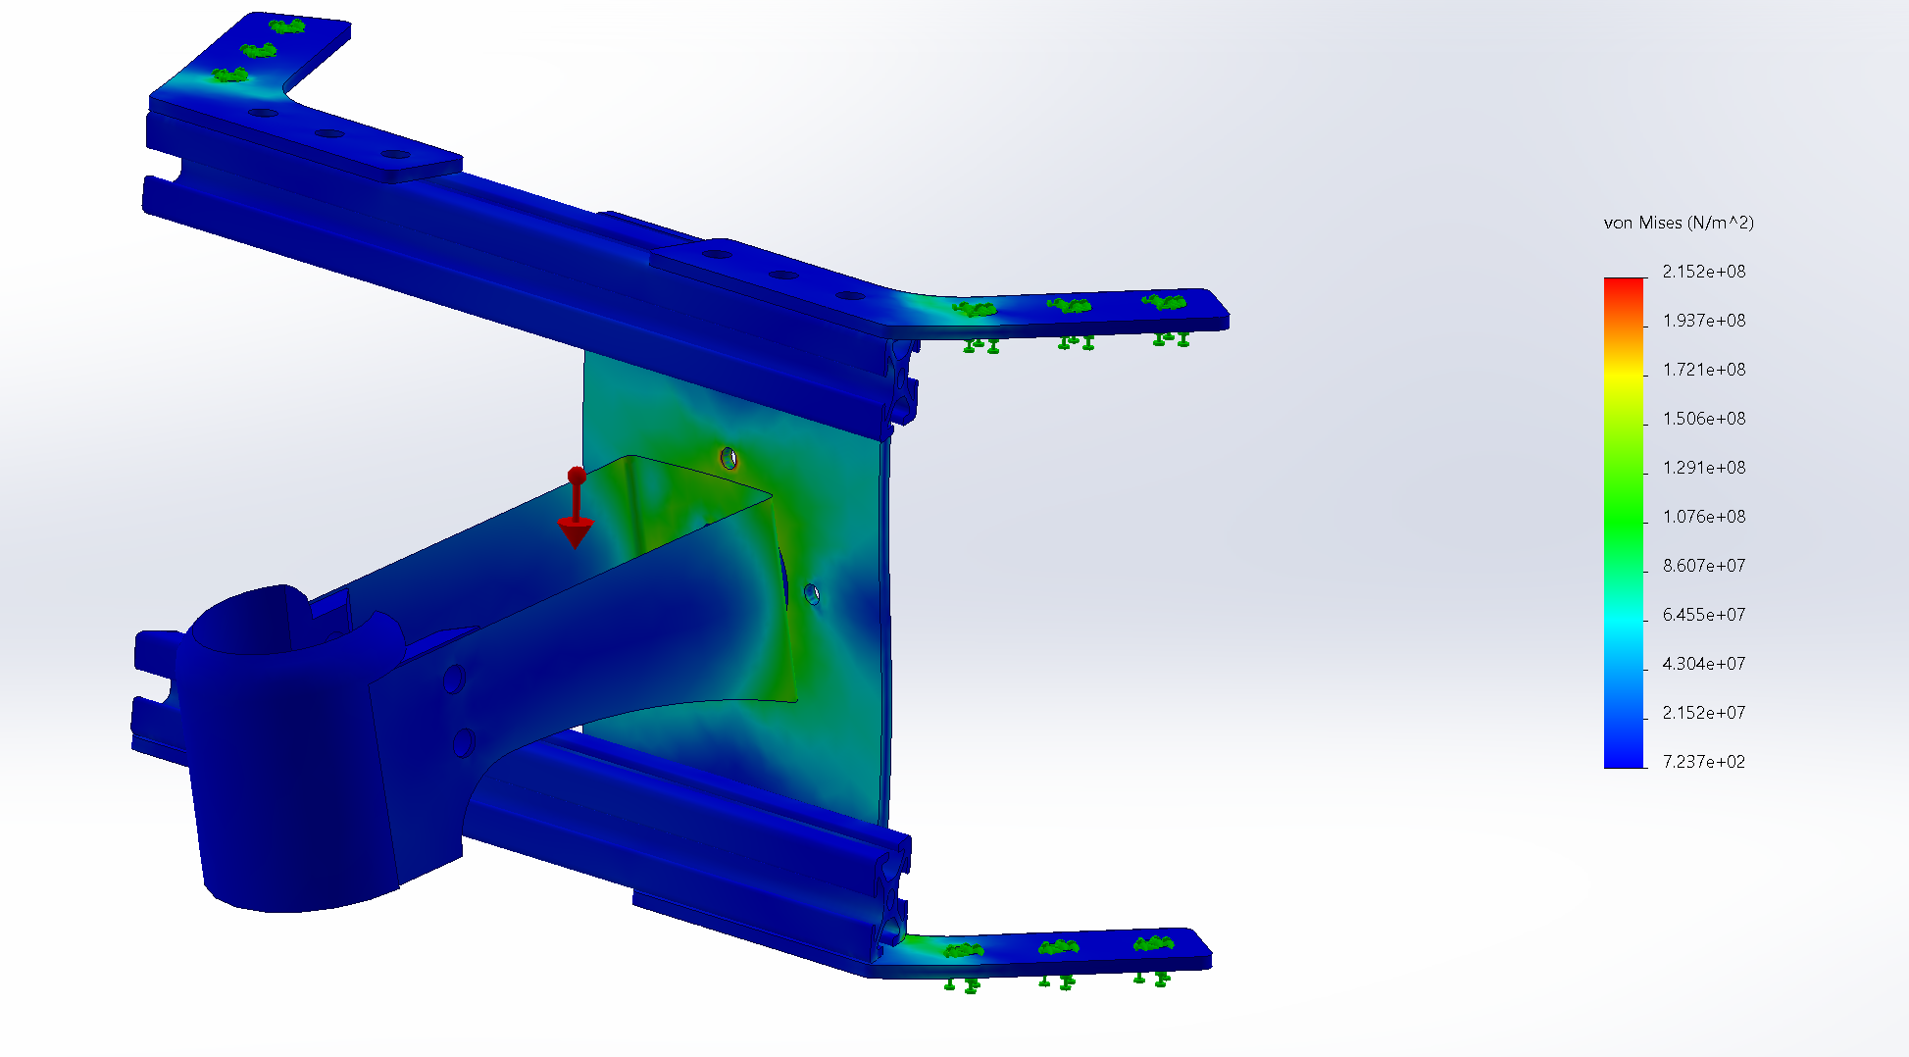

**Figure 24.** Stress heat map for a 90-pound force acting on the thruster clamp acting downward with the thruster arm vertical (team-fig)

Lastly, the team tested the thrusters to ensure their functionality. The thrusters required 300 VDc at 1.5 Amps each to operate at full capacity, however, the highest power output the team could find on campus was the Zach Common Labs power wall which could output 120 VDc at 5 Amps. Tecandyne assured the team that powering the thrusters at 120 Vdc for a short period would not significantly damage them. The team attempted to test the thrusters at the power wall, however, as this was the first time the team used the power wall, a supervisor needed to be present. The supervisor who would’ve helped the team was not around during the testing time, so the team was unable to test the thrusters. This unfortunately leaves the testing of the thrusters to the following team.

# Safety/Hazard Assessment and Evaluation

Ensuring the safety of the subsea ROV and its operators was a primary concern throughout the design, construction, and testing phases. One of the earliest discussions centered around safety during the construction stage, particularly during material cutting and shaping. These tasks posed the highest risk of physical injury and were therefore conducted exclusively in the FEDC workshop under the supervision of trained personnel.

Operational hazards associated with the ROV primarily relate to its electrical systems and propulsion mechanisms. The ROV is equipped with high-powered thrusters capable of generating significant force to maintain consistent underwater movement. However, this force can present injury risks if proper precautions are not taken. Additionally, the electrical components of the ROV must be thoroughly insulated to prevent exposure to water and mitigate the risk of electric shock during wiring or testing operations. Ensuring secure, waterproof connections and eliminating loose wiring are critical steps in reducing the potential for electrical hazards from the tether or onboard systems.

From a mechanical safety standpoint, it is imperative to maintain a clear area around the thrusters at all times. Foreign objects caught in the propulsion system can cause damage to both the thrusters and surrounding equipment, or lead to breakage due to the high rotational force of the blades.

To address these concerns, comprehensive risk mitigation strategies must be implemented throughout the lifecycle of the ROV. During construction, this includes careful attention to electrical safety, such as ensuring intact insulation, proper grounding of conductive components, use of personal protective equipment, and adherence to established safety protocols. During testing, regular inspections for signs of wear, damaged insulation, or loose wiring are essential. Maintenance procedures should be followed rigorously, and all ROV handling should occur in dry, controlled environments. In addition, operators should undergo thorough safety training.

To minimize risks associated with the thrusters, it is essential to keep them free from obstruction. If an object becomes lodged in a thruster, power to the system must be cut immediately. The obstruction should be removed carefully using non-conductive tools, such as a plastic or rubber-handled screwdriver, to ensure the safety of the individual performing the task.

Through consistent application of these precautions and practices, the safety of both the ROV and its operators can be significantly enhanced during all phases of its operation.

# Reliability Assessment

With a multitude of interfacing components and moving parts being used in a harsh environment such as the deep ocean, reliability is an important design consideration to implement into the engineering process. A common set of factors that tradeoffs regarding ROVs in the industry are the number of parts, number of repairs, time working, and time being repaired. ROVs are only useful when they are engaged in working tasks, which leaves repair periods, surfacing, and submerging as non-profitable time. This means designing the ROV in a way that is conscious of the time (and profit) that is lost due to the ROV surfacing, being maintained, and submerging again.

One potential design concern with this next-generation ROV (Remotely Operated Vehicle) is the outward protrusion of its thrusters. While this configuration may provide improved maneuverability and thrust efficiency, it also introduces a significant operational risk, especially in complex underwater environments. In scenarios such as offshore oilfield operations, ROVs are often required to navigate in close proximity to pipelines, the seabed, coral reefs, or other submerged structures. During these missions, the ROV may need to descend to the ocean floor to perform maintenance, inspections, or repairs on pipelines and related infrastructure.

In such settings, the exposed position of the thrusters could make them vulnerable to accidental contact with underwater obstacles. Collisions could occur either during descent, repositioning, or while operating in tight spaces. This contact could damage the thruster components—such as the propeller blades or motor housings—or, worse, lead to debris becoming lodged within the thruster mechanisms. Over time, repeated or unnoticed impacts could degrade performance or cause complete thruster failure.

Should one or more thrusters become inoperable, the ROV’s ability to maneuver effectively would be compromised. In severe cases, the unit might become immobilized or irretrievably stuck in difficult terrain, posing a serious risk to mission success and asset recovery. As such, careful consideration of thruster placement, the addition of protective shielding, or implementing smart collision-avoidance systems may be necessary to mitigate these risks and ensure operational reliability in complex underwater environments.

# Societal Factors and Impact

The subsea ROV brings several significant impacts, both positive and negative. ROVs are primarily used to conduct inspection and maintenance on offshore oil and natural gas rigs, as the depths are too extreme to be traversed by piloted watercraft. The oil and gas industry is critical to everyday life, with fossil fuels being the source of power for most everything used and interacted with daily. The ability to increase the efficiency that work is done on these rigs to ensure that procurement of our most important resources is not inhibited allows for more security in the things that all people interact with to be working more efficiently in every way. Being able to use the ROV’s improved dexterity and visibility to pick up on issues with drill equipment will have a positive effect on the safety of the operators on the rigs, if faults are able to be detected earlier and more easily and frequently, allowing them to be corrected before a major failure causes a disaster that puts operator lives at risk as well as major environmental damage in prevention. The world of marine research may be able to benefit from an ROV that can reach more difficult environments to provide us with greater knowledge of the oceans that surround us.

The ability to move, observe, and perform tasks underwater much like a human diver presents a major advantage: it can potentially replace the need for divers in many operations. While divers are not currently employed to work on offshore equipment at extreme depths, the ocean is an inherently dangerous environment. ROVs are a way to eliminate the risks associated with sending people underwater with oxygen tanks, such as decompression sickness, equipment failure, or other life-threatening hazards. The next-gen ROV will be able to function much more parallel to a human diver due to design elements put in place, which could allow for the use of ROVs at shallower depths, keeping more lives out of harm’s way. Additionally, using an ROV could greatly reduce the extensive training, certifications, and preparation normally required for underwater work. This shift could lead to lower operational costs and fewer man-hours spent in hazardous environments.

However, the use of ROVs also carries potential drawbacks. If a malfunction occurs underwater, such as an electrical failure, it could have harmful effects on marine life. An electrical component, if damaged and exposed to the surrounding water could injure, disorient, or even kill nearby wildlife, particularly species that are highly sensitive to electric fields. Beyond environmental impacts, there are also social and economic considerations. As ROVs take over tasks traditionally performed by divers, professional divers may face reduced job opportunities, leading to economic displacement in industries that have long relied on human expertise underwater.

# 

# Future Work

This project is a multi-year endeavor, so future work is already laid out. The main components have had design input by the end of the 2024-2025 year. The future groups will be refining designs for the camera system, manipulator, chassis, and propulsion system to come together functionally with an optimized skillset. The main tasks that will follow this year are systems engineering and systems and component integration. The meat of the electronics is still to be designed, with providing power to the components on the ROV itself. Creating a tether system that works well and doesn’t interfere with the design requirements is also a need, as well as determining the system for tracking buoyancy and stability automatically, and relaying info through the tether to the operator via the cameras and other sensors. The thrusters must be paired to work together, as well as the manipulator must be programmed to function to industry expectations. Much more is to be done to see this ROV project through. Making the many parts of the ROV work together will pose quite a challenge to the coming groups, but with the resources available at Texas A&M it should have an impressive outcome.

**Table 4.** Future work areas that will be covered in coming years

| **System or**  **Sub-System** | **Area of Work** | **Need** | **Comment** |
| --- | --- | --- | --- |
| Directional Control | Control Systems | Will need to create a system that connects the operator to the rotary actuators and thrusters. | Critical to the design requirements of the capabilities of the human-like next-gen ROV. |
| Manipulator Control | Control Systems | Will need to design the placement of the manipulator on the ROV chassis and its electronics. | Necessary for expected ROV industry functions. |
| Camera Control | Control Systems | Will need to progress on the mounting, circuit, and system design of the 360-degree visibility characteristic of the ROV. | Also critical to the design requirements of the next-gen ROV. |
| Connecting Components & Systems | Systems/Component Integration | Items such as interfacing the cameras with the VR headset, working each thruster together, the tether to the operator and ROV, the manipulator to the ROV, etc. | Most likely be a large chunk of the phase it is part of. |
| Testing Connections | Systems/Component Integration | Testing the tether functionality and ability to allow mobility and not restrict. Testing thruster/rotary actuators under stressful inputs. Testing manipulator/ROV connection under stressful inputs. | Important to determine failure points throughout the ROV. |
| Thruster Operation | Operational Testing | Test the operation of the thrusters at various voltages. | The thrusters are 18 years old and need to be tested to ensure their functionality. |
| Camera Operation | Operational Testing | The camera and operator viewing must be tested to ensure the 360-degree field of view. | Data transfer between the ROV and the operator must be accurate, reliable, and fast. |
| Control Functions | Operational Testing | The controls of the ROV must be tested to ensure the ROV meets the customer's requirements. | Real testing of complete subsystems begins. |
| In-water Testing | Performance Testing | ROV must be put through the paces to be proven as an underwater craft capable of completing tasks in harsh environments. | This is the final stage of the project. Will be the culmination of all aspects. |

# Team and Project Organization, Planning, and Execution

The team adopted several different strategies to organize, plan, and execute our project. Flexible but defined roles were implemented in team management and organization, as well as in the design process. Task organization used both a WBS and a Gantt chart, as well as dividing up the tasks based on the design roles. Communication consisted of standard messaging applications such as SMS text, and email for quick and informal information. Email was also used to communicate with vendors, sponsors, and other parties providing information, with team members CC’d consistently to ensure all were provided key information as the semester progressed. Microsoft Teams as well as Google applications were utilized to store files and provide new information to all team members.

Team roles were defined as the following set. David Scott was the primary team lead on the organizational side, primarily concerned with communication with sponsors and parts ordering as well as scheduling. On the design side, he helped with the manufacturing, though this came second to duties as team lead. Marcus Navas was the CAE lead organizationally and in charge of the CAD design; two tasks which overlap considerably. Most of the CAD images present in this document are from him. Heath Garett was in charge of financial documentation and planning organizationally and his design focus was the frame. Bobby Clukey was the minute/note taker for meetings, did much of the assembly, and helped with the CAD design, as well as the propulsion subsystem. The first set of duties was more prominent at the beginning of the semester, and the second set towards the end. Finally, Eric Bauman was in charge of the electrical systems design-wise, and did additional administrative tasks organizationally. These tasks were often scheduling and inquiries related to the electrical systems. Although these were the main areas of focus for each team member, the exact roles blended throughout the capstone to allow team members to learn multiple different aspects of the ROV.

The team used both a WBS and a Gantt chart to create an outline of tasks for the two-semester process. These documents are presented here:

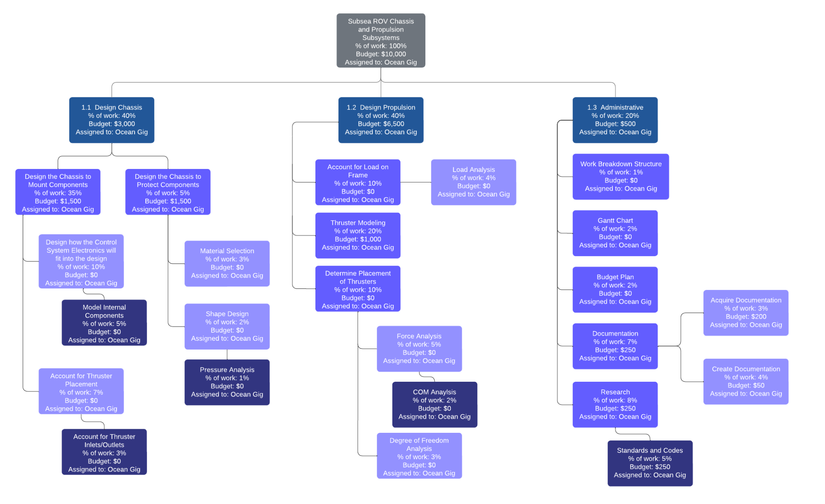

**Figure 25.** The WBS for the design and manufacturing process. (team-fig)

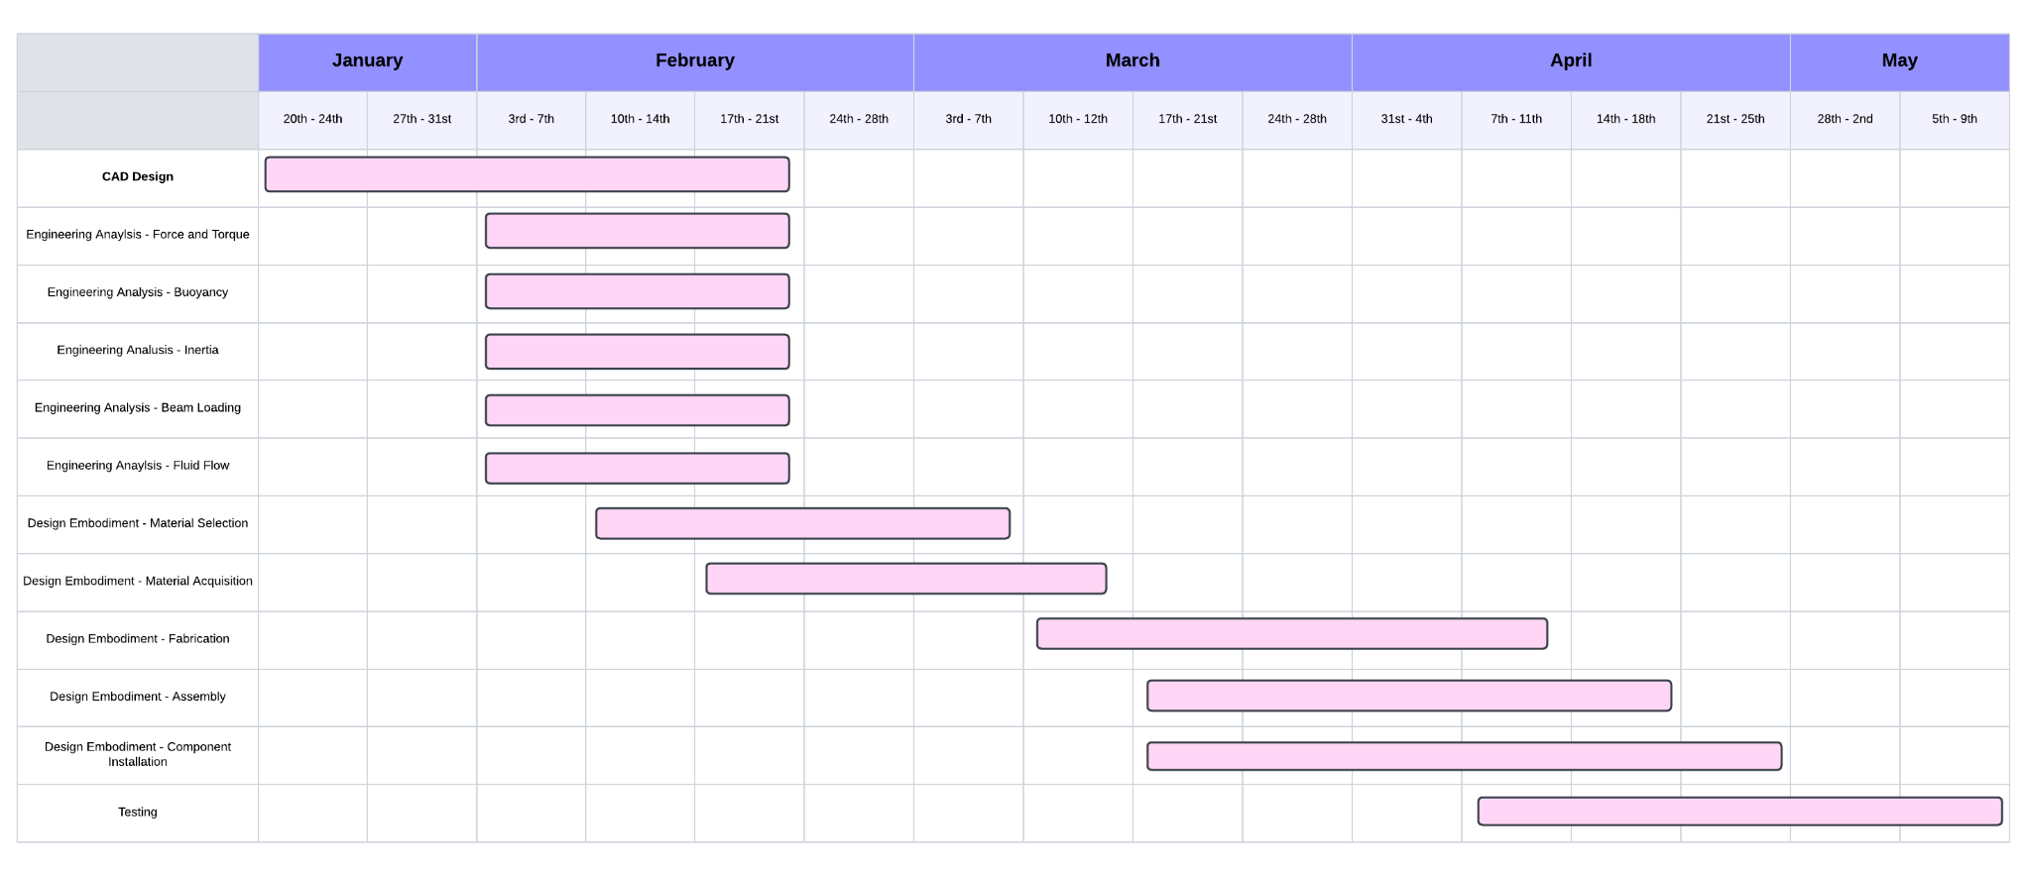

**Figure 26.** The projected Gantt chart for the semester. (team-fig)

The WBS accounts for how the various tasks will be split between the three areas of the propulsion system, the chassis, and other administrative tasks. This rough division of labor was mostly consistent with who the work fell to (Chassis work to Bobby, Marcus, and Heath, administrative work to David, and propulsion work to Eric).

The Gantt chart shows the projected tasks to be done in the semester in a slightly different format, with time to complete and ordering accounted for. The term “projected” is used because the actual execution of these tasks often fell at different times than the ones presented on the chart, especially towards the end of the semester. The actual dates for some of these tasks are shown here:

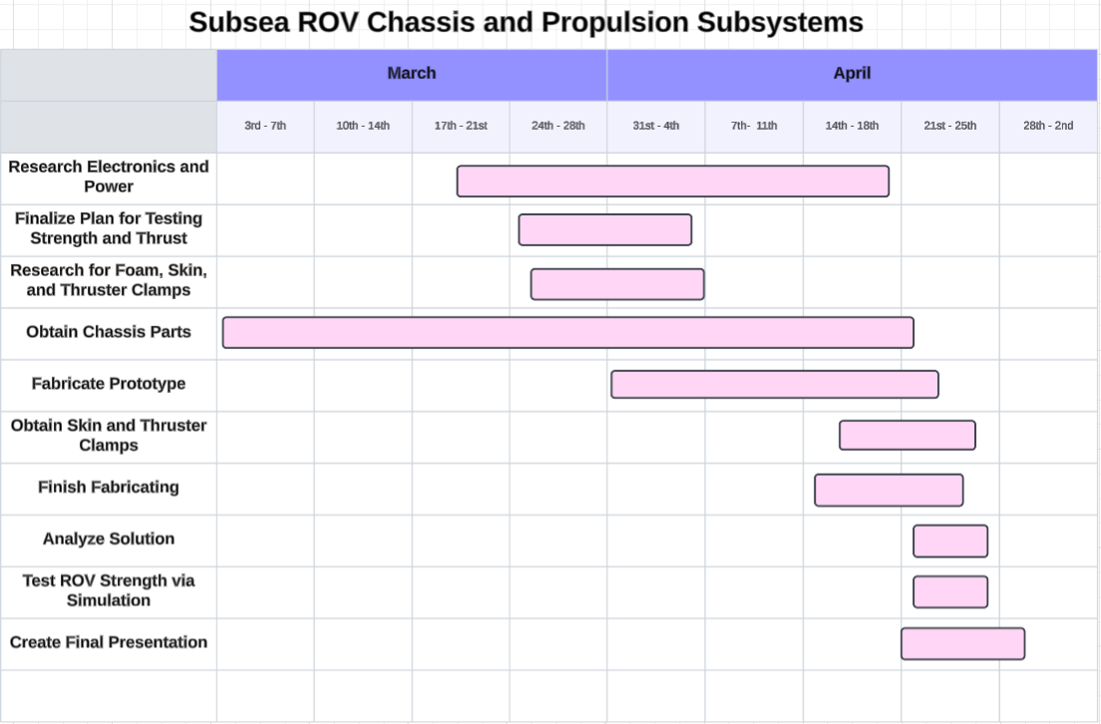

**Figure 27.** The actual completion times for tasks are between March and April. (team-fig)

As is visible in this chart, the procurement of the parts to assemble the chassis took much longer than expected, nearly a month and a half. This caused delays in several other areas of the project, most notably assembly. While the Gantt chart from the beginning of the semester was a good starting point, it did not account for unknown potential delays beyond what it had accounted for, requiring flexibility to complete what we completed on time. This delay in the procurement of parts caused the fabrication and testing of the ROV to be significantly constrained in time.

Most work meetings were conducted during studio time, including sponsor meetings, organized by David, with Bobby as a note-taker. When not in those meetings, organization and communication were accomplished over email, through text, or use of the messaging platform Discord.

# Summary

When divers operate underwater, they encounter numerous hazards inherent to the environment. To reduce these risks, underwater remotely operated vehicles (ROVs) have been developed to minimize the need for direct human involvement in dangerous conditions. However, current ROVs lack the ability to move and perceive their surroundings with the same flexibility and precision as a human diver. The objective of this project was to develop an ROV capable of replicating diver-like movement and performing tasks typically executed by divers. The specific focus for this team was the design and construction of the chassis and propulsion systems.

At the start of the semester, preliminary progress had been made in computer-aided design (CAD), and many analytical aspects of the project had been outlined. However, all work up to that point remained theoretical, with no physical components assembled. The only available hardware consisted of thrusters that had been generously donated, as well as the electronics to power these thrusters.

This report presents the analytical diagrams and charts used to identify critical needs, functions, and design solutions that contributed to the development of the final product. It also includes financial documentation to confirm the project remained within budget, along with a detailed overview of the ROV’s construction process.

The completed project resulted in a fully built ROV chassis with thrusters capable of providing six degrees of freedom. This configuration enables the ROV to maneuver through water in a manner that closely simulates the movements of a human diver. With this completed model, the team was able to test the 6-degrees of freedom of the ROV, the strength of the ROV, and attempted to test the force output of the thrusters given different power inputs.

To achieve a functional prototype, the next team in the capstone will perform control analysis using the thrusters and rotary actuators and the final team will perform system integration to ensure the visual, chassis, propulsion, and manipulator subsystems all work together. The team was unable to test the thrusters because of complications with the supervisor, meaning the controls team will need to perform the tests on the thrusters.

Special recognition is extended to Professor William Ledbetter and Mr. Don Wells for their generous support throughout the project, and to Dr. Andrew Conkey and Professor Oscar Lopez for their assistance throughout the capstone project. Appreciation is also given to members of Oceaneering International, Inc. for their valuable insights and willingness to share their expertise in subsea ROV technology.

# 

# 

# Appendix

## A. List of Abbreviations and Terminology

CNC: Computer Numerical Control

DOF: Degrees Of Freedom

FAD: Function analysis diagram

Full Depth Rated: Rated to withstand the pressures at the bottom of the Marianas Trench, the deepest part of the ocean.

Propwash: The effect that thrusters have on the fluids passing through them. This effect makes the fluids rotate in a spiral pattern after passing through the propeller.

ROV: Remotely Operated Vehicle

SWOT: Strengths, Weaknesses, Opportunities, and Threats

Tether (Umbilical): The wired connection between the ROV and the pilot on the surface which powers the ROV and controls the thruster directions and powers.

WBS: Work Breakdown Structure

## B. References

[1] Oceaneering International, 2024, “Analyzing the Ocean Gig Prototype Design in Relation to Current Industry Standards.”

[2] International Marine Contractors Association, 2025, “IMCA International Code of Practice for Offshore Diving,” IMCA.

[3] International Marine Contractors Association, 2023, “Code of Practice for the Safe Use of Electricity under Water,” IMCA.

[4] International Marine Contractors Association, 2021, “Recommended Practice for the Use of High Pressure Jetting Equipment by Divers,” ICMA.

[5] International Marine Contractors Association, 2021, “Remotely Operated Vehicle Intervention during Diving Operations,” IMCA.

[6] International Marine Contractors Association, 2024, “The Safe and Efficient Operation of Remotely Operated Vehicles,” IMCA.

[7] International Marine Contractors Association, 2021, “ROV Mobilisation,” IMCA [Online]. Available: https://www.imca-int.com/resources/technical-library/document/04883c5f-c55b-ee11-8dee-6045bdd0ef45/

[8] American Society for Testing and Materials, 2025, “Design and Operation of Subsea Production Systems,” ASTM.

[9] American Society for Testing and Materials, 2025, “Remotely Operated Tools and Interfaces on Subsea Production Systems,” ASTM.

[10] American Society for Testing and Materials, 2025, “Recommended Practice for Subsea Structures and Manifolds,” ASTM.

[11] American Society for Testing and Materials, 2025, “Recommended Practice for Analysis, Design, Installation, and Testing of Safety Systems for Subsea Applications,” ASTM.

## C. Order of Magnitude and Detailed Calculations



**Figure C.1.** Calculations of Archimedes’ Principle in SolidWorks. (team-fig)

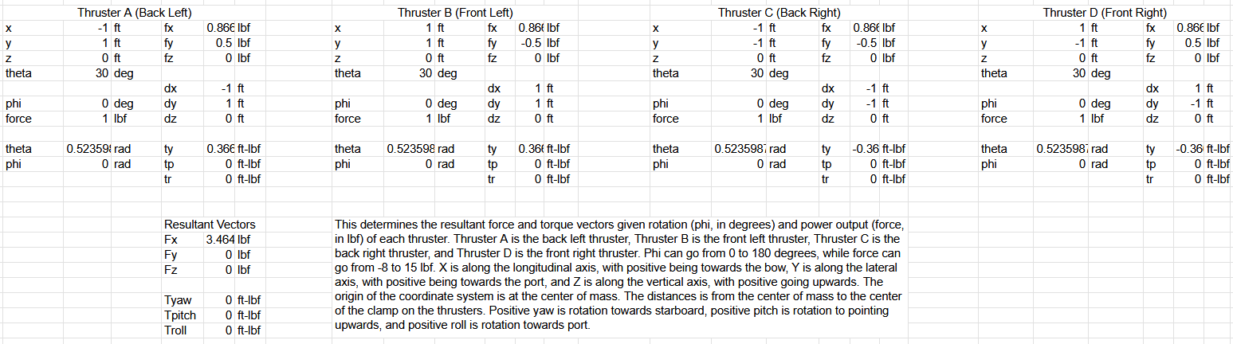

**Figure C.2.** Excel representation of the resultant force and torque vectors given thruster positions and output forces. This instance shows the resultant forces and torques when all four thrusters are pointing forward and outputting 1 lbf of thrust. Enlarged image shown in **Figure F.1**. (team-fig)

## E. Detailed working drawings/models/assembly



**Figure E.1.** Enlarged model of the wiring diagram for the thruster power and control system

## F. Testing/Validating/Verification/Experimentation



**Figure F.1.** Enlarged representation of the resultant force and torque vectors given thruster positions and output forces. This instance shows the resultant forces and torques when all four thrusters are pointing forward and outputting 1 lbf of thrust. (team-fig)